V. Right of Publicity 2
A. State Right of Publicity Statutory Provisions 3
B. Right of Publicity Case Law 6
White v. Samsung Electronics America, Inc. 9
White v. Samsung Electronics America, Inc. 17
In re NCAA Student–Athlete Name & Likeness Licensing Litigation 30

V. Right of Publicity
The right of publicity protects a person’s identity against unauthorized commercial exploitation. See J. Thomas McCarthy, The Rights of Publicity and Privacy §1:3 (2d ed. Apr. 2014) (defining the right of publicity as “the inherent right of every human being to control the commercial use of his or her identity”). There is no federal right of publicity, though as we will see below, Lanham Act § 43(a), 15 U.S.C. § 1125(a), may form the basis for a cause of action akin to one that protects publicity rights. Right of publicity claims are typically pursued under state common law or state statutory law. Thirty-three of the fifty states provide some form of right of publicity protection, either through common law protection, state statutory protection, or both.

Right of Publicity Law by State (as of April 2017)
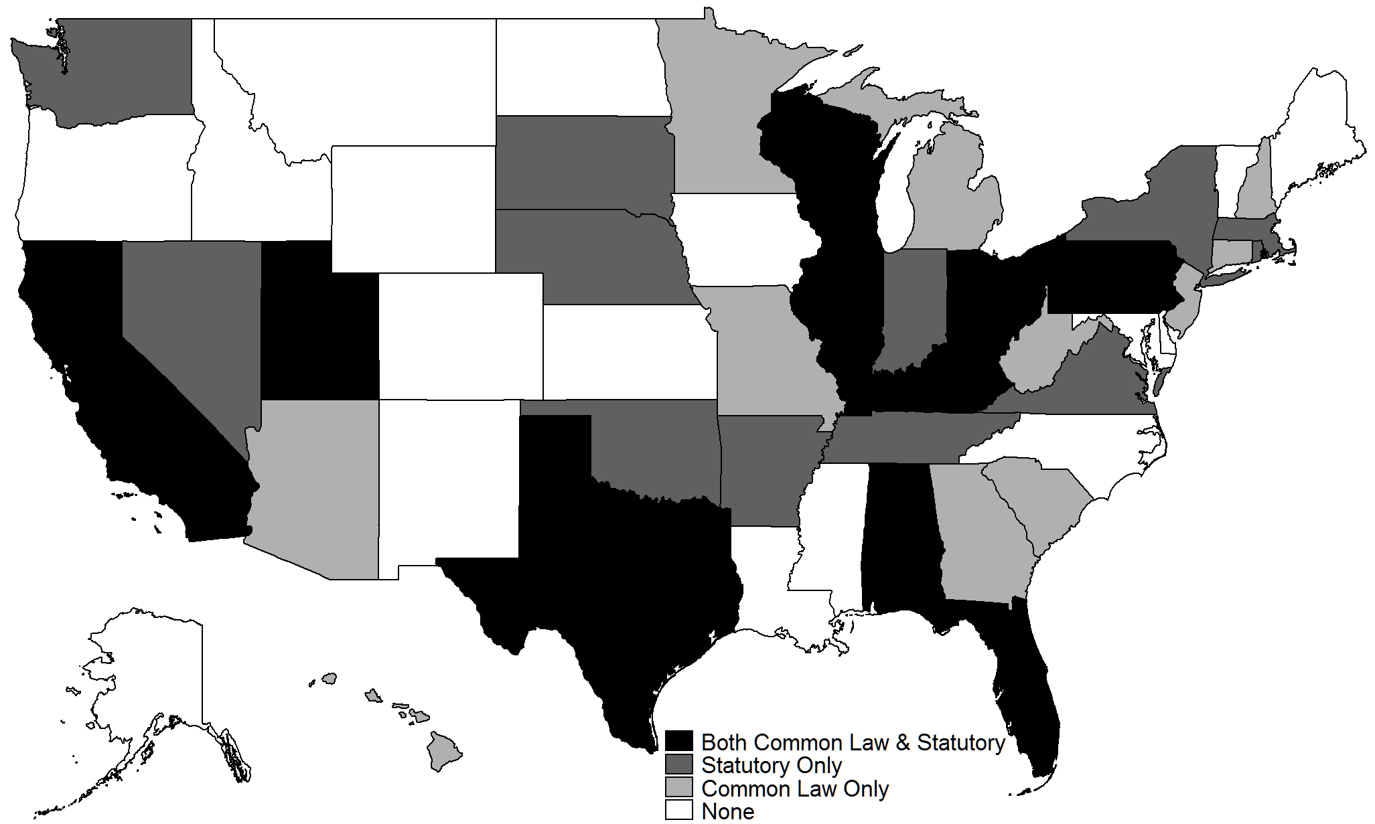

Because of their importance to the entertainment and media industries, and because their differences are typical of the differences among the laws of the many states, California and New York’s schemes of publicity rights protection are detailed below.
But before delving into the specifics of the right of publicity, it may be worthwhile to ask: why should we protect a person’s identity from unauthorized commercial exploitation? Borrowing from trademark law, should we do so simply to prevent false endorsements that may mislead consumers as to who is actually endorsing a product? See generally Stacey L. Dogan & Mark A. Lemley, What the Right of Publicity Can Learn from Trademark Law, 58 Stan. L. Rev. 1161 (2006). Or are there further, independent justifications? Some commentators have proposed moral or ethical rationales for the right of publicity, based on an individual’s human right to privacy or on an individual’s right to autonomous self-definition—so that a sportsman opposed to alcohol should not have to see his identity used to promote alcoholic beverages. See e.g., Mark McKenna, The Right of Publicity and Autonomous Self-Definition, 67 U. Pitt. L. Rev. 225 (2005); but see O’Brien v. Pabst Sales Co., 124 F.2d 167 (5th Cir. 1941) (denying football player Davy O’Brien’s privacy-based right of publicity claim against a beer producer). Others have proposed a Lockean justification for the right of publicity, in that the unauthorized exploitation of someone’s identity constitutes a misappropriation of the fruits of the labor of whoever created that identity. See Michael Madow, Private Ownership of Public Image, 81 Cal. L. Rev. 127 (1993) (discussing but not endorsing this view). Commentators have also proposed economic justifications for the right of publicity, based on the proposition that the right of publicity provides an economic incentive to celebrities to do more and better of whatever it is that makes them celebrities, or that the right of publicity prevents “congestion externalities,” i.e., the dilution of the distinctiveness of a celebrity’s identity that might occur if that identity is associated with too many products or services. See William M. Landes & Richard A. Posner, The Economic Structure of Intellectual Property Law 222-228 (2003). (In what sense is antidilution law essentially a right of publicity scheme of protection for brand names?).
Which of these rationales for the right of publicity strikes you as the most or least persuasive?

A. State Right of Publicity Statutory Provisions
New York’s right of publicity statute, excerpted below, is generally understood to be based on the individual’s right to privacy. Accordingly, New York law does not provide for the descendibilty of the right of publicity, which ceases in New York with the death of the individual. By contrast, California’s statute, also excerpted below, is generally understood to conceive of the right of publicity as a property right, which is descendible for 70 years after the death of the individual. Cal. Civ. Code. § 3344.1(g). Commentators routinely declare California’s right of publicity to be freely assignable, while the New York case law has not clearly established the assignability of the right in New York, but recent scholarship has suggested that the alienability of the right of publicity is considerably more complicated across the states. See Jennifer E. Rothman, The Inalienable Right of Publicity, 101 Georgetown L.J. 185 (2012).

N.Y. Civil Rights Law § 51. Action for injunction and for damages
Any person whose name, portrait, picture or voice is used within this state for advertising purposes or for the purposes of trade without the written consent first obtained as above provided may maintain an equitable action in the supreme court of this state against the person, firm or corporation so using his name, portrait, picture or voice, to prevent and restrain the use thereof; and may also sue and recover damages for any injuries sustained by reason of such use and if the defendant shall have knowingly used such person's name, portrait, picture or voice in such manner as is forbidden or declared to be unlawful by section fifty of this article, the jury, in its discretion, may award exemplary damages. But nothing contained in this article shall be so construed as to prevent any person, firm or corporation from selling or otherwise transferring any material containing such name, portrait, picture or voice in whatever medium to any user of such name, portrait, picture or voice, or to any third party for sale or transfer directly or indirectly to such a user, for use in a manner lawful under this article; nothing contained in this article shall be so construed as to prevent any person, firm or corporation, practicing the profession of photography, from exhibiting in or about his or its establishment specimens of the work of such establishment, unless the same is continued by such person, firm or corporation after written notice objecting thereto has been given by the person portrayed; and nothing contained in this article shall be so construed as to prevent any person, firm or corporation from using the name, portrait, picture or voice of any manufacturer or dealer in connection with the goods, wares and merchandise manufactured, produced or dealt in by him which he has sold or disposed of with such name, portrait, picture or voice used in connection therewith; or from using the name, portrait, picture or voice of any author, composer or artist in connection with his literary, musical or artistic productions which he has sold or disposed of with such name, portrait, picture or voice used in connection therewith. Nothing contained in this section shall be construed to prohibit the copyright owner of a sound recording from disposing of, dealing in, licensing or selling that sound recording to any party, if the right to dispose of, deal in, license or sell such sound recording has been conferred by contract or other written document by such living person or the holder of such right. Nothing contained in the foregoing sentence shall be deemed to abrogate or otherwise limit any rights or remedies otherwise conferred by federal law or state law.

California Civil Code §§ 3344 & 3344.1.
§ 3344. Use of another's name, voice, signature, photograph, or likeness for advertising or selling or soliciting purposes
(a) Any person who knowingly uses another's name, voice, signature, photograph, or likeness, in any manner, on or in products, merchandise, or goods, or for purposes of advertising or selling, or soliciting purchases of, products, merchandise, goods or services, without such person's prior consent, or, in the case of a minor, the prior consent of his parent or legal guardian, shall be liable for any damages sustained by the person or persons injured as a result thereof. In addition, in any action brought under this section, the person who violated the section shall be liable to the injured party or parties in an amount equal to the greater of seven hundred fifty dollars ($750) or the actual damages suffered by him or her as a result of the unauthorized use, and any profits from the unauthorized use that are attributable to the use and are not taken into account in computing the actual damages. In establishing such profits, the injured party or parties are required to present proof only of the gross revenue attributable to such use, and the person who violated this section is required to prove his or her deductible expenses. Punitive damages may also be awarded to the injured party or parties. The prevailing party in any action under this section shall also be entitled to attorney's fees and costs.
(b) As used in this section, “photograph” means any photograph or photographic reproduction, still or moving, or any videotape or live television transmission, of any person, such that the person is readily identifiable.
(1) A person shall be deemed to be readily identifiable from a photograph when one who views the photograph with the naked eye can reasonably determine that the person depicted in the photograph is the same person who is complaining of its unauthorized use.
(2) If the photograph includes more than one person so identifiable, then the person or persons complaining of the use shall be represented as individuals rather than solely as members of a definable group represented in the photograph. A definable group includes, but is not limited to, the following examples: a crowd at any sporting event, a crowd in any street or public building, the audience at any theatrical or stage production, a glee club, or a baseball team.
(3) A person or persons shall be considered to be represented as members of a definable group if they are represented in the photograph solely as a result of being present at the time the photograph was taken and have not been singled out as individuals in any manner.
(c) Where a photograph or likeness of an employee of the person using the photograph or likeness appearing in the advertisement or other publication prepared by or in behalf of the user is only incidental, and not essential, to the purpose of the publication in which it appears, there shall arise a rebuttable presumption affecting the burden of producing evidence that the failure to obtain the consent of the employee was not a knowing use of the employee's photograph or likeness.
(d) For purposes of this section, a use of a name, voice, signature, photograph, or likeness in connection with any news, public affairs, or sports broadcast or account, or any political campaign, shall not constitute a use for which consent is required under subdivision (a).
(e) The use of a name, voice, signature, photograph, or likeness in a commercial medium shall not constitute a use for which consent is required under subdivision (a) solely because the material containing such use is commercially sponsored or contains paid advertising. Rather it shall be a question of fact whether or not the use of the person's name, voice, signature, photograph, or likeness was so directly connected with the commercial sponsorship or with the paid advertising as to constitute a use for which consent is required under subdivision (a).
(f) Nothing in this section shall apply to the owners or employees of any medium used for advertising, including, but not limited to, newspapers, magazines, radio and television networks and stations, cable television systems, billboards, and transit ads, by whom any advertisement or solicitation in violation of this section is published or disseminated, unless it is established that such owners or employees had knowledge of the unauthorized use of the person's name, voice, signature, photograph, or likeness as prohibited by this section.
(g) The remedies provided for in this section are cumulative and shall be in addition to any others provided for by law.
§ 3344.1. Deceased personality's name, voice, signature, photograph, or likeness; unauthorized use; damages and profits from use; protected uses; persons entitled to exercise rights; successors in interest or licensees; registration of claim
…
(a)(2) For purposes of this subdivision, a play, book, magazine, newspaper, musical composition, audiovisual work, radio or television program, single and original work of art, work of political or newsworthy value, or an advertisement or commercial announcement for any of these works, shall not be considered a product, article of merchandise, good, or service if it is fictional or nonfictional entertainment, or a dramatic, literary, or musical work.
…
(j) For purposes of this section, the use of a name, voice, signature, photograph, or likeness in connection with any news, public affairs, or sports broadcast or account, or any political campaign, shall not constitute a use for which consent is required under subdivision (a).

B. Right of Publicity Case Law
Provided below are opinions from two significant right of publicity cases. The first, older case is White v. Samsung Electronics America, Inc., 971 F.2d 1395 (9th Cir. 1992), which addressed television hostess Vanna White’s claims that a series of Samsung advertisement’s featuring a robot likeness of her violated her intellectual property rights. Excerpted below is the Ninth Circuit’s majority opinion in the case and Judge Kozinski’s dissent from a denial of en banc review of that majority opinion. The second case, In re NCAA Student–Athlete Name & Likeness Licensing Litigation, 724 F.3d 1268 (9th Cir. 2013), is of much more recent vintage and was issued on the same day as Brown v. Electronic Arts, 724 F.3d 1235 (9th Cir. 2013), which, you will recall from Part III.C.2 above, rejected retired football player Jim Brown’s Lanham Act § 43(a) claim against a video game producer who used his likeness in a video game. By contrast, in In re NCAA Student-Athlete Name & Likeness Licensing (sometimes known as the “Keller case”), the court addressed a California Civil Code § 3344 claim against the video game producer brought by a one-time college football player. As you will see, the California right of publicity claim was more successful than Jim Brown’s Lanham Act § 43(a) claim.
As you read through the White v. Samsung opinions, consider the following questions:
- If you are persuaded by the simple false endorsement justification for right of publicity protection, then does White v. Samsung support that justification? Does Samsung’s homage to Vanna White constitute false endorsement? How might a court properly determine the answer to this latter question?
- In Midler v. Ford Motor Co., 849 F.2d 460 (9th Cir.1988) and Waits v. Frito-Lay, Inc., 978 F.2d 1093 (9th Cir.1992), the defendants employed impersonators to mimic the singing styles of Bette Midler and Tom Waits, respectively, both of whom adamantly refuse to allow their art to be used to sell goods and services. Defendants were found liable under Lanham Act § 43(a) in both cases. If you are persuaded by Judge Kozinski’s dissent, then how would you rule in Midler and Waits?

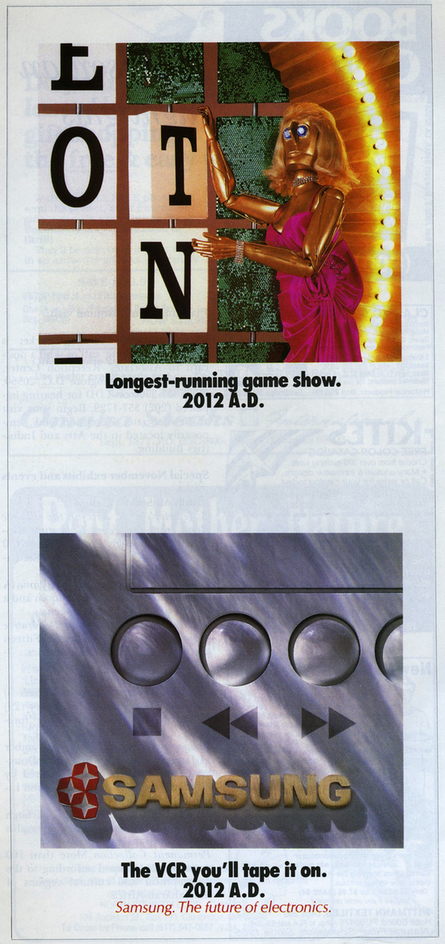

White v. Samsung Electronics America, Inc.
971 F.2d 1395 (9th Cir. 1992)
GOODWIN, Senior Circuit Judge:
[1] This case involves a promotional “fame and fortune” dispute. In running a particular advertisement without Vanna White's permission, defendants Samsung Electronics America, Inc. (Samsung) and David Deutsch Associates, Inc. (Deutsch) attempted to capitalize on White's fame to enhance their fortune. White sued, alleging infringement of various intellectual property rights, but the district court granted summary judgment in favor of the defendants. We affirm in part, reverse in part, and remand.
[2] Plaintiff Vanna White is the hostess of “Wheel of Fortune,” one of the most popular game shows in television history. An estimated forty million people watch the program daily. Capitalizing on the fame which her participation in the show has bestowed on her, White markets her identity to various advertisers.
[3] The dispute in this case arose out of a series of advertisements prepared for Samsung by Deutsch. The series ran in at least half a dozen publications with widespread, and in some cases national, circulation. Each of the advertisements in the series followed the same theme. Each depicted a current item from popular culture and a Samsung electronic product. Each was set in the twenty-first century and conveyed the message that the Samsung product would still be in use by that time. By hypothesizing outrageous future outcomes for the cultural items, the ads created humorous effects. For example, one lampooned current popular notions of an unhealthy diet by depicting a raw steak with the caption: “Revealed to be health food. 2010 A.D.” Another depicted irreverent “news”-show host Morton Downey Jr. in front of an American flag with the caption: “Presidential candidate. 2008 A.D.”
[4] The advertisement which prompted the current dispute was for Samsung video-cassette recorders (VCRs). The ad depicted a robot, dressed in a wig, gown, and jewelry which Deutsch consciously selected to resemble White's hair and dress. The robot was posed next to a game board which is instantly recognizable as the Wheel of Fortune game show set, in a stance for which White is famous. The caption of the ad read: “Longest-running game show. 2012 A.D.” Defendants referred to the ad as the “Vanna White” ad. Unlike the other celebrities used in the campaign, White neither consented to the ads nor was she paid.
[5] Following the circulation of the robot ad, White sued Samsung and Deutsch in federal district court under: (1) California Civil Code § 3344; (2) the California common law right of publicity; and (3) § 43(a) of the Lanham Act, 15 U.S.C. § 1125(a). The district court granted summary judgment against White on each of her claims. White now appeals.

I. Section 3344
[6] White first argues that the district court erred in rejecting her claim under section 3344. Section 3344(a) provides, in pertinent part, that “[a]ny person who knowingly uses another's name, voice, signature, photograph, or likeness, in any manner, ... for purposes of advertising or selling, ... without such person's prior consent ... shall be liable for any damages sustained by the person or persons injured as a result thereof.”
[7] White argues that the Samsung advertisement used her “likeness” in contravention of section 3344. In Midler v. Ford Motor Co., 849 F.2d 460 (9th Cir.1988), this court rejected Bette Midler's section 3344 claim concerning a Ford television commercial in which a Midler “sound-alike” sang a song which Midler had made famous. In rejecting Midler's claim, this court noted that “[t]he defendants did not use Midler's name or anything else whose use is prohibited by the statute. The voice they used was [another person's], not hers. The term ‘likeness' refers to a visual image not a vocal imitation.” Id. at 463.
[8] In this case, Samsung and Deutsch used a robot with mechanical features, and not, for example, a manikin molded to White's precise features. Without deciding for all purposes when a caricature or impressionistic resemblance might become a “likeness,” we agree with the district court that the robot at issue here was not White's “likeness” within the meaning of section 3344. Accordingly, we affirm the court's dismissal of White's section 3344 claim.

II. Right of Publicity
[9] White next argues that the district court erred in granting summary judgment to defendants on White's common law right of publicity claim. In Eastwood v. Superior Court, 149 Cal.App.3d 409, 198 Cal.Rptr. 342 (1983), the California court of appeal stated that the common law right of publicity cause of action “may be pleaded by alleging (1) the defendant's use of the plaintiff's identity; (2) the appropriation of plaintiff's name or likeness to defendant's advantage, commercially or otherwise; (3) lack of consent; and (4) resulting injury.” Id. at 417, 198 Cal.Rptr. 342 (citing Prosser, Law of Torts (4th ed. 1971) § 117, pp. 804–807). The district court dismissed White's claim for failure to satisfy Eastwood's second prong, reasoning that defendants had not appropriated White's “name or likeness” with their robot ad. We agree that the robot ad did not make use of White's name or likeness. However, the common law right of publicity is not so confined.
[10] The Eastwood court did not hold that the right of publicity cause of action could be pleaded only by alleging an appropriation of name or likeness. Eastwood involved an unauthorized use of photographs of Clint Eastwood and of his name. Accordingly, the Eastwood court had no occasion to consider the extent beyond the use of name or likeness to which the right of publicity reaches. That court held only that the right of publicity cause of action “may be” pleaded by alleging, inter alia, appropriation of name or likeness, not that the action may be pleaded only in those terms.
[11] The “name or likeness” formulation referred to in Eastwood originated not as an element of the right of publicity cause of action, but as a description of the types of cases in which the cause of action had been recognized. The source of this formulation is Prosser, Privacy, 48 Cal.L.Rev. 383, 401–07 (1960), one of the earliest and most enduring articulations of the common law right of publicity cause of action. In looking at the case law to that point, Prosser recognized that right of publicity cases involved one of two basic factual scenarios: name appropriation, and picture or other likeness appropriation. Id. at 401–02, nn. 156–57.
[12] Even though Prosser focused on appropriations of name or likeness in discussing the right of publicity, he noted that “[i]t is not impossible that there might be appropriation of the plaintiff's identity, as by impersonation, without the use of either his name or his likeness, and that this would be an invasion of his right of privacy.” Id. at 401, n. 155. At the time Prosser wrote, he noted however, that “[n]o such case appears to have arisen.” Id.
[13] Since Prosser's early formulation, the case law has borne out his insight that the right of publicity is not limited to the appropriation of name or likeness. In Motschenbacher v. R.J. Reynolds Tobacco Co., 498 F.2d 821 (9th Cir.1974), the defendant had used a photograph of the plaintiff's race car in a television commercial. Although the plaintiff appeared driving the car in the photograph, his features were not visible. Even though the defendant had not appropriated the plaintiff's name or likeness, this court held that plaintiff's California right of publicity claim should reach the jury.
[14] In Midler, this court held that, even though the defendants had not used Midler's name or likeness, Midler had stated a claim for violation of her California common law right of publicity because “the defendants ... for their own profit in selling their product did appropriate part of her identity” by using a Midler sound-alike. Id. at 463–64.
[15] In Carson v. Here's Johnny Portable Toilets, Inc., 698 F.2d 831 (6th Cir.1983), the defendant had marketed portable toilets under the brand name “Here's Johnny”—Johnny Carson's signature “Tonight Show” introduction—without Carson's permission. The district court had dismissed Carson's Michigan common law right of publicity claim because the defendants had not used Carson's “name or likeness.” Id. at 835. In reversing the district court, the sixth circuit found “the district court's conception of the right of publicity ... too narrow” and held that the right was implicated because the defendant had appropriated Carson's identity by using, inter alia, the phrase “Here's Johnny.” Id. at 835–37.
[16] These cases teach not only that the common law right of publicity reaches means of appropriation other than name or likeness, but that the specific means of appropriation are relevant only for determining whether the defendant has in fact appropriated the plaintiff's identity. The right of publicity does not require that appropriations of identity be accomplished through particular means to be actionable. It is noteworthy that the Midler and Carson defendants not only avoided using the plaintiff's name or likeness, but they also avoided appropriating the celebrity's voice, signature, and photograph. The photograph in Motschenbacher did include the plaintiff, but because the plaintiff was not visible the driver could have been an actor or dummy and the analysis in the case would have been the same.
[17] Although the defendants in these cases avoided the most obvious means of appropriating the plaintiffs' identities, each of their actions directly implicated the commercial interests which the right of publicity is designed to protect. As the Carson court explained:
[t]he right of publicity has developed to protect the commercial interest of celebrities in their identities. The theory of the right is that a celebrity's identity can be valuable in the promotion of products, and the celebrity has an interest that may be protected from the unauthorized commercial exploitation of that identity.... If the celebrity's identity is commercially exploited, there has been an invasion of his right whether or not his “name or likeness” is used.
Carson, 698 F.2d at 835. It is not important how the defendant has appropriated the plaintiff's identity, but whether the defendant has done so. Motschenbacher, Midler, and Carson teach the impossibility of treating the right of publicity as guarding only against a laundry list of specific means of appropriating identity. A rule which says that the right of publicity can be infringed only through the use of nine different methods of appropriating identity merely challenges the clever advertising strategist to come up with the tenth.
[18] Indeed, if we treated the means of appropriation as dispositive in our analysis of the right of publicity, we would not only weaken the right but effectively eviscerate it. The right would fail to protect those plaintiffs most in need of its protection. Advertisers use celebrities to promote their products. The more popular the celebrity, the greater the number of people who recognize her, and the greater the visibility for the product. The identities of the most popular celebrities are not only the most attractive for advertisers, but also the easiest to evoke without resorting to obvious means such as name, likeness, or voice.
[19] Consider a hypothetical advertisement which depicts a mechanical robot with male features, an African–American complexion, and a bald head. The robot is wearing black hightop Air Jordan basketball sneakers, and a red basketball uniform with black trim, baggy shorts, and the number 23 (though not revealing “Bulls” or “Jordan” lettering). The ad depicts the robot dunking a basketball one-handed, stiff-armed, legs extended like open scissors, and tongue hanging out. Now envision that this ad is run on television during professional basketball games. Considered individually, the robot's physical attributes, its dress, and its stance tell us little. Taken together, they lead to the only conclusion that any sports viewer who has registered a discernible pulse in the past five years would reach: the ad is about Michael Jordan.
[20] Viewed separately, the individual aspects of the advertisement in the present case say little. Viewed together, they leave little doubt about the celebrity the ad is meant to depict. The female-shaped robot is wearing a long gown, blond wig, and large jewelry. Vanna White dresses exactly like this at times, but so do many other women. The robot is in the process of turning a block letter on a game-board. Vanna White dresses like this while turning letters on a game-board but perhaps similarly attired Scrabble-playing women do this as well. The robot is standing on what looks to be the Wheel of Fortune game show set. Vanna White dresses like this, turns letters, and does this on the Wheel of Fortune game show. She is the only one. Indeed, defendants themselves referred to their ad as the “Vanna White” ad. We are not surprised.
[21] Television and other media create marketable celebrity identity value. Considerable energy and ingenuity are expended by those who have achieved celebrity value to exploit it for profit. The law protects the celebrity's sole right to exploit this value whether the celebrity has achieved her fame out of rare ability, dumb luck, or a combination thereof. We decline Samsung and Deutch's invitation to permit the evisceration of the common law right of publicity through means as facile as those in this case. Because White has alleged facts showing that Samsung and Deutsch had appropriated her identity, the district court erred by rejecting, on summary judgment, White's common law right of publicity claim.

III. The Lanham Act
[22] White's final argument is that the district court erred in denying her claim under § 43(a) of the Lanham Act, 15 U.S.C. § 1125(a). The version of section 43(a) applicable to this case provides, in pertinent part, that “[a]ny person who shall ... use, in connection with any goods or services ... any false description or representation ... shall be liable to a civil action ... by any person who believes that he is or is likely to be damaged by the use of any such false description or designation.” 15 U.S.C. § 1125(a).
[23] To prevail on her Lanham Act claim, White is required to show that in running the robot ad, Samsung and Deutsch created a likelihood of confusion, Academy of Motion Picture Arts v. Creative House, 944 F.2d 1446, 1454 (9th Cir.1991); Toho Co. Ltd. v. Sears Roebuck & Co., 645 F.2d 788, 790 (9th Cir.1981) New West Corp. v. NYM Co. of California, 595 F.2d 1194, 1201 (9th Cir.1979), over whether White was endorsing Samsung's VCRs. HMH Publishing Co. v. Brincat, 504 F.2d 713 (9th Cir.1974); Allen v. National Video, Inc., 610 F.Supp. 612 (D.C.N.Y.1985).
[24] This circuit recognizes several different multi-factor tests for determining whether a likelihood of confusion exists. See Academy, 944 F.2d at 1454, n. 3. None of these tests is correct to the exclusion of the others. Eclipse Associates Ltd. v. Data General Corp., 894 F.2d 1114, 1118 (9th Cir.1990). Normally, in reviewing the district court's decision, this court will look to the particular test that the district court used. Academy, 944 F.2d at 1454, n. 3; Eclipse, 894 F.2d at 1117–1118. However, because the district court in this case apparently did not use any of the multi-factor tests in making its likelihood of confusion determination, and because this case involves an appeal from summary judgment and we review de novo the district court's determination, we will look for guidance to the 8–factor test enunciated in AMF, Inc. v. Sleekcraft Boats, 599 F.2d 341 (9th Cir.1979). According to AMF, factors relevant to a likelihood of confusion include:
(1) strength of the plaintiff's mark;
(2) relatedness of the goods;
(3) similarity of the marks;
(4) evidence of actual confusion;
(5) marketing channels used;
(6) likely degree of purchaser care;
(7) defendant's intent in selecting the mark;
(8) likelihood of expansion of the product lines.
599 F.2d at 348–49. We turn now to consider White's claim in light of each factor.
[25] In cases involving confusion over endorsement by a celebrity plaintiff, “mark” means the celebrity's persona. See Allen, 610 F.Supp. at 627. The “strength” of the mark refers to the level of recognition the celebrity enjoys among members of society. See Academy, 944 F.2d at 1455. If Vanna White is unknown to the segment of the public at whom Samsung's robot ad was directed, then that segment could not be confused as to whether she was endorsing Samsung VCRs. Conversely, if White is well-known, this would allow the possibility of a likelihood of confusion. For the purposes of the Sleekcraft test, White's “mark,” or celebrity identity, is strong.
[26] In cases concerning confusion over celebrity endorsement, the plaintiff's “goods” concern the reasons for or source of the plaintiff's fame. Because White's fame is based on her televised performances, her “goods” are closely related to Samsung's VCRs. Indeed, the ad itself reinforced the relationship by informing its readers that they would be taping the “longest-running game show” on Samsung's VCRs well into the future.
[27] The third factor, “similarity of the marks,” both supports and contradicts a finding of likelihood of confusion. On the one hand, all of the aspects of the robot ad identify White; on the other, the figure is quite clearly a robot, not a human. This ambiguity means that we must look to the other factors for resolution.
[28] The fourth factor does not favor White's claim because she has presented no evidence of actual confusion.
[29] Fifth, however, White has appeared in the same stance as the robot from the ad in numerous magazines, including the covers of some. Magazines were used as the marketing channels for the robot ad. This factor cuts toward a likelihood of confusion.
[30] Sixth, consumers are not likely to be particularly careful in determining who endorses VCRs, making confusion as to their endorsement more likely.
[31] Concerning the seventh factor, “defendant's intent,” the district court found that, in running the robot ad, the defendants had intended a spoof of the “Wheel of Fortune.” The relevant question is whether the defendants “intended to profit by confusing consumers” concerning the endorsement of Samsung VCRs. Toho, 645 F.2d 788. We do not disagree that defendants intended to spoof Vanna White and “Wheel of Fortune.” That does not preclude, however, the possibility that defendants also intended to confuse consumers regarding endorsement. The robot ad was one of a series of ads run by defendants which followed the same theme. Another ad in the series depicted Morton Downey Jr. as a presidential candidate in the year 2008. Doubtless, defendants intended to spoof presidential elections and Mr. Downey through this ad. Consumers, however, would likely believe, and would be correct in so believing, that Mr. Downey was paid for his permission and was endorsing Samsung products. Looking at the series of advertisements as a whole, a jury could reasonably conclude that beneath the surface humor of the series lay an intent to persuade consumers that celebrity Vanna White, like celebrity Downey, was endorsing Samsung products.
[32] Finally, the eighth factor, “likelihood of expansion of the product lines,” does not appear apposite to a celebrity endorsement case such as this.
[33] Application of the Sleekcraft factors to this case indicates that the district court erred in rejecting White's Lanham Act claim at the summary judgment stage. In so concluding, we emphasize two facts, however. First, construing the motion papers in White's favor, as we must, we hold only that White has raised a genuine issue of material fact concerning a likelihood of confusion as to her endorsement. Cohen v. Paramount Pictures Corp., 845 F.2d 851, 852–53 (9th Cir.1988). Whether White's Lanham Act claim should succeed is a matter for the jury. Second, we stress that we reach this conclusion in light of the peculiar facts of this case. In particular, we note that the robot ad identifies White and was part of a series of ads in which other celebrities participated and were paid for their endorsement of Samsung's products.

IV. The Parody Defense
[34] In defense, defendants cite a number of cases for the proposition that their robot ad constituted protected speech. The only cases they cite which are even remotely relevant to this case are Hustler Magazine v. Falwell, 485 U.S. 46, 108 S.Ct. 876, 99 L.Ed.2d 41 (1988) and L.L. Bean, Inc. v. Drake Publishers, Inc., 811 F.2d 26 (1st Cir.1987). Those cases involved parodies of advertisements run for the purpose of poking fun at Jerry Falwell and L.L. Bean, respectively. This case involves a true advertisement run for the purpose of selling Samsung VCRs. The ad's spoof of Vanna White and Wheel of Fortune is subservient and only tangentially related to the ad's primary message: “buy Samsung VCRs.” Defendants' parody arguments are better addressed to non-commercial parodies. The difference between a “parody” and a “knock-off” is the difference between fun and profit.

V. Conclusion
[35] In remanding this case, we hold only that White has pleaded claims which can go to the jury for its decision.
AFFIRMED IN PART, REVERSED IN PART, and REMANDED.
[Judge Alarcon’s dissent is not included.]

----------------------------------------------------

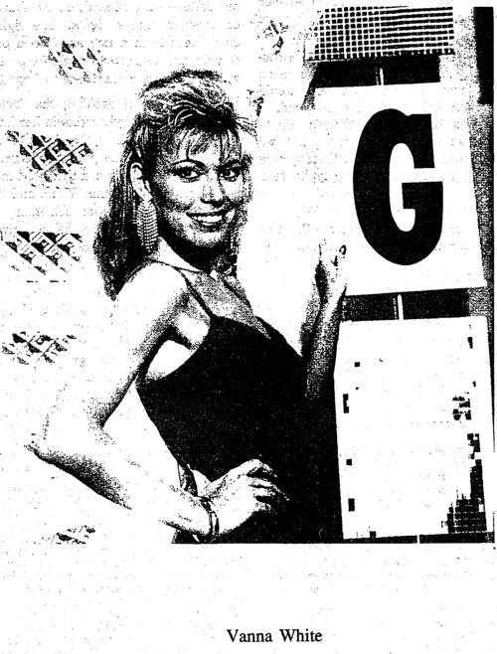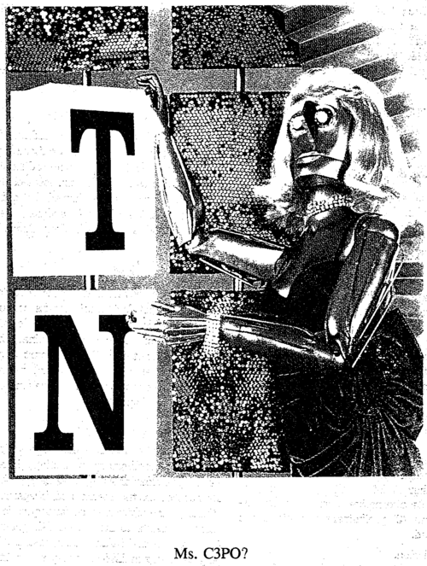

White v. Samsung Electronics America, Inc.
989 F.2d 1512 (9th Cir. 1993)
Before GOODWIN, PREGERSON and ALARCON, Circuit Judges.
[1] The panel has voted unanimously to deny the petition for rehearing. Circuit Judge Pregerson has voted to reject the suggestion for rehearing en banc, and Circuit Judge Goodwin so recommends. Circuit Judge Alarcon has voted to accept the suggestion for rehearing en banc.
[2] The full court has been advised of the suggestion for rehearing en banc. An active judge requested a vote on whether to rehear the matter en banc. The matter failed to receive a majority of the votes of the nonrecused active judges in favor of en banc consideration. Fed.R.App.P. 35.
[3] The petition for rehearing is DENIED and the suggestion for rehearing en banc is REJECTED.

KOZINSKI, Circuit Judge, with whom Circuit Judges O'SCANNLAIN and KLEINFELD join, dissenting from the order rejecting the suggestion for rehearing en banc.

I
Saddam Hussein wants to keep advertisers from using his picture in unflattering contexts. Clint Eastwood doesn't want tabloids to write about him. Rudolf Valentino's heirs want to control his film biography. The Girl Scouts don't want their image soiled by association with certain activities. George Lucas wants to keep Strategic Defense Initiative fans from calling it “Star Wars.” Pepsico doesn't want singers to use the word “Pepsi” in their songs. Guy Lombardo wants an exclusive property right to ads that show big bands playing on New Year's Eve. Uri Geller thinks he should be paid for ads showing psychics bending metal through telekinesis. Paul Prudhomme, that household name, thinks the same about ads featuring corpulent bearded chefs. And scads of copyright holders see purple when their creations are made fun of.
[4] Something very dangerous is going on here. Private property, including intellectual property, is essential to our way of life. It provides an incentive for investment and innovation; it stimulates the flourishing of our culture; it protects the moral entitlements of people to the fruits of their labors. But reducing too much to private property can be bad medicine. Private land, for instance, is far more useful if separated from other private land by public streets, roads and highways. Public parks, utility rights-of-way and sewers reduce the amount of land in private hands, but vastly enhance the value of the property that remains.
[5] So too it is with intellectual property. Overprotecting intellectual property is as harmful as underprotecting it. Creativity is impossible without a rich public domain. Nothing today, likely nothing since we tamed fire, is genuinely new: Culture, like science and technology, grows by accretion, each new creator building on the works of those who came before. Overprotection stifles the very creative forces it's supposed to nurture.
[6] The panel's opinion is a classic case of overprotection. Concerned about what it sees as a wrong done to Vanna White, the panel majority erects a property right of remarkable and dangerous breadth: Under the majority's opinion, it's now a tort for advertisers to remind the public of a celebrity. Not to use a celebrity's name, voice, signature or likeness; not to imply the celebrity endorses a product; but simply to evoke the celebrity's image in the public's mind. This Orwellian notion withdraws far more from the public domain than prudence and common sense allow. It conflicts with the Copyright Act and the Copyright Clause. It raises serious First Amendment problems. It's bad law, and it deserves a long, hard second look.

II
[7] Samsung ran an ad campaign promoting its consumer electronics. Each ad depicted a Samsung product and a humorous prediction: One showed a raw steak with the caption “Revealed to be health food. 2010 A.D.” Another showed Morton Downey, Jr. in front of an American flag with the caption “Presidential candidate. 2008 A.D.” The ads were meant to convey—humorously—that Samsung products would still be in use twenty years from now.
[8] The ad that spawned this litigation starred a robot dressed in a wig, gown and jewelry reminiscent of Vanna White's hair and dress; the robot was posed next to a Wheel-of-Fortune-like game board. See Appendix. The caption read “Longest-running game show. 2012 A.D.” The gag here, I take it, was that Samsung would still be around when White had been replaced by a robot.
[9] Perhaps failing to see the humor, White sued, alleging Samsung infringed her right of publicity by “appropriating” her “identity.” Under California law, White has the exclusive right to use her name, likeness, signature and voice for commercial purposes. Cal.Civ.Code § 3344(a); Eastwood v. Superior Court, 149 Cal.App.3d 409, 417, 198 Cal.Rptr. 342, 347 (1983). But Samsung didn't use her name, voice or signature, and it certainly didn't use her likeness. The ad just wouldn't have been funny had it depicted White or someone who resembled her—the whole joke was that the game show host(ess) was a robot, not a real person. No one seeing the ad could have thought this was supposed to be White in 2012.
[10] The district judge quite reasonably held that, because Samsung didn't use White's name, likeness, voice or signature, it didn't violate her right of publicity. 971 F.2d at 1396-97. Not so, says the panel majority: The California right of publicity can't possibly be limited to name and likeness. If it were, the majority reasons, a “clever advertising strategist” could avoid using White's name or likeness but nevertheless remind people of her with impunity, “effectively eviscerat[ing]” her rights. To prevent this “evisceration,” the panel majority holds that the right of publicity must extend beyond name and likeness, to any “appropriation” of White's “identity”—anything that “evoke[s]” her personality. Id. at 1398-99.

III
[11] But what does “evisceration” mean in intellectual property law? Intellectual property rights aren't like some constitutional rights, absolute guarantees protected against all kinds of interference, subtle as well as blatant. They cast no penumbras, emit no emanations: The very point of intellectual property laws is that they protect only against certain specific kinds of appropriation. I can't publish unauthorized copies of, say, Presumed Innocent; I can't make a movie out of it. But I'm perfectly free to write a book about an idealistic young prosecutor on trial for a crime he didn't commit. So what if I got the idea from Presumed Innocent? So what if it reminds readers of the original? Have I “eviscerated” Scott Turow's intellectual property rights? Certainly not. All creators draw in part on the work of those who came before, referring to it, building on it, poking fun at it; we call this creativity, not piracy.
[12] The majority isn't, in fact, preventing the “evisceration” of Vanna White's existing rights; it's creating a new and much broader property right, a right unknown in California law. It's replacing the existing balance between the interests of the celebrity and those of the public by a different balance, one substantially more favorable to the celebrity. Instead of having an exclusive right in her name, likeness, signature or voice, every famous person now has an exclusive right to anything that reminds the viewer of her. After all, that's all Samsung did: It used an inanimate object to remind people of White, to “evoke [her identity].” 971 F.2d at 1399.
[13] Consider how sweeping this new right is. What is it about the ad that makes people think of White? It's not the robot's wig, clothes or jewelry; there must be ten million blond women (many of them quasi-famous) who wear dresses and jewelry like White's. It's that the robot is posed near the “Wheel of Fortune” game board. Remove the game board from the ad, and no one would think of Vanna White. See Appendix. But once you include the game board, anybody standing beside it-a brunette woman, a man wearing women's clothes, a monkey in a wig and gown-would evoke White's image, precisely the way the robot did. It's the “Wheel of Fortune” set, not the robot's face or dress or jewelry that evokes White's image. The panel is giving White an exclusive right not in what she looks like or who she is, but in what she does for a living.
[14] This is entirely the wrong place to strike the balance. Intellectual property rights aren't free: They're imposed at the expense of future creators and of the public at large. Where would we be if Charles Lindbergh had an exclusive right in the concept of a heroic solo aviator? If Arthur Conan Doyle had gotten a copyright in the idea of the detective story, or Albert Einstein had patented the theory of relativity? If every author and celebrity had been given the right to keep people from mocking them or their work? Surely this would have made the world poorer, not richer, culturally as well as economically.
[15] This is why intellectual property law is full of careful balances between what's set aside for the owner and what's left in the public domain for the rest of us: The relatively short life of patents; the longer, but finite, life of copyrights; copyright's idea-expression dichotomy; the fair use doctrine; the prohibition on copyrighting facts; the compulsory license of television broadcasts and musical compositions; federal preemption of overbroad state intellectual property laws; the nominative use doctrine in trademark law; the right to make soundalike recordings. All of these diminish an intellectual property owner's rights. All let the public use something created by someone else. But all are necessary to maintain a free environment in which creative genius can flourish.
[16] The intellectual property right created by the panel here has none of these essential limitations: No fair use exception; no right to parody; no idea-expression dichotomy. It impoverishes the public domain, to the detriment of future creators and the public at large. Instead of well-defined, limited characteristics such as name, likeness or voice, advertisers will now have to cope with vague claims of “appropriation of identity,” claims often made by people with a wholly exaggerated sense of their own fame and significance. See pp. 1512-13 & notes 1-10 supra. Future Vanna Whites might not get the chance to create their personae, because their employers may fear some celebrity will claim the persona is too similar to her own. The public will be robbed of parodies of celebrities, and our culture will be deprived of the valuable safety valve that parody and mockery create.
[17] Moreover, consider the moral dimension, about which the panel majority seems to have gotten so exercised. Saying Samsung “appropriated” something of White's begs the question: Should White have the exclusive right to something as broad and amorphous as her “identity”? Samsung's ad didn't simply copy White's schtick-like all parody, it created something new. True, Samsung did it to make money, but White does whatever she does to make money, too; the majority talks of “the difference between fun and profit,” 971 F.2d at 1401, but in the entertainment industry fun is profit. Why is Vanna White's right to exclusive for-profit use of her persona—a persona that might not even be her own creation, but that of a writer, director or producer—superior to Samsung's right to profit by creating its own inventions? Why should she have such absolute rights to control the conduct of others, unlimited by the idea-expression dichotomy or by the fair use doctrine?
[18] To paraphrase only slightly Feist Publications, Inc. v. Rural Telephone Service Co., 499 U.S. 340 (1991), it may seem unfair that much of the fruit of a creator's labor may be used by others without compensation. But this is not some unforeseen byproduct of our intellectual property system; it is the system's very essence. Intellectual property law assures authors the right to their original expression, but encourages others to build freely on the ideas that underlie it. This result is neither unfair nor unfortunate: It is the means by which intellectual property law advances the progress of science and art. We give authors certain exclusive rights, but in exchange we get a richer public domain. The majority ignores this wise teaching, and all of us are the poorer for it.
IV
[19] The panel, however, does more than misinterpret California law: By refusing to recognize a parody exception to the right of publicity, the panel directly contradicts the federal Copyright Act. Samsung didn't merely parody Vanna White. It parodied Vanna White appearing in “Wheel of Fortune,” a copyrighted television show, and parodies of copyrighted works are governed by federal copyright law.
[20] Copyright law specifically gives the world at large the right to make “fair use” parodies, parodies that don't borrow too much of the original. Fisher v. Dees, 794 F.2d 432, 435 (9th Cir.1986).…

VI
[21] Finally, I can't see how giving White the power to keep others from evoking her image in the public's mind can be squared with the First Amendment. Where does White get this right to control our thoughts? The majority's creation goes way beyond the protection given a trademark or a copyrighted work, or a person's name or likeness. All those things control one particular way of expressing an idea, one way of referring to an object or a person. But not allowing any means of reminding people of someone? That's a speech restriction unparalleled in First Amendment law.
[22] What's more, I doubt even a name-and-likeness-only right of publicity can stand without a parody exception. The First Amendment isn't just about religion or politics—it's also about protecting the free development of our national culture. Parody, humor, irreverence are all vital components of the marketplace of ideas. The last thing we need, the last thing the First Amendment will tolerate, is a law that lets public figures keep people from mocking them, or from “evok[ing]” their images in the mind of the public. 971 F.2d at 1399.
[23] The majority dismisses the First Amendment issue out of hand because Samsung's ad was commercial speech. Id. at 1401 & n. 3. So what? Commercial speech may be less protected by the First Amendment than noncommercial speech, but less protected means protected nonetheless. CentralHudson Gas & Elec. Corp. v. Public Serv. Comm'n, 447 U.S. 557, 100 S.Ct. 2343, 65 L.Ed.2d 341 (1980). And there are very good reasons for this. Commercial speech has a profound effect on our culture and our attitudes. Neutral-seeming ads influence people's social and political attitudes, and themselves arouse political controversy. “Where's the Beef?” turned from an advertising catchphrase into the only really memorable thing about the 1984 presidential campaign. Four years later, Michael Dukakis called George Bush “the Joe Isuzu of American politics.”
[24] In our pop culture, where salesmanship must be entertaining and entertainment must sell, the line between the commercial and noncommercial has not merely blurred; it has disappeared. Is the Samsung parody any different from a parody on Saturday Night Live or in Spy Magazine? Both are equally profit-motivated. Both use a celebrity's identity to sell things—one to sell VCRs, the other to sell advertising. Both mock their subjects. Both try to make people laugh. Both add something, perhaps something worthwhile and memorable, perhaps not, to our culture. Both are things that the people being portrayed might dearly want to suppress. See notes 1 & 29 supra.
[25] Commercial speech is a significant, valuable part of our national discourse. The Supreme Court has recognized as much, and has insisted that lower courts carefully scrutinize commercial speech restrictions, but the panel totally fails to do this. The panel majority doesn't even purport to apply the Central Hudson test, which the Supreme Court devised specifically for determining whether a commercial speech restriction is valid. The majority doesn't ask, as Central Hudson requires, whether the speech restriction is justified by a substantial state interest. It doesn't ask whether the restriction directly advances the interest. It doesn't ask whether the restriction is narrowly tailored to the interest. See id. at 566. These are all things the Supreme Court told us—in no uncertain terms—we must consider; the majority opinion doesn't even mention them.
[26] Process matters. The Supreme Court didn't set out the Central Hudson test for its health. It devised the test because it saw lower courts were giving the First Amendment short shrift when confronted with commercial speech. See Central Hudson, 447 U.S. at 561-62, 567-68, 100 S.Ct. at 2348-49, 2352. The Central Hudson test was an attempt to constrain lower courts' discretion, to focus judges' thinking on the important issues—how strong the state interest is, how broad the regulation is, whether a narrower regulation would work just as well. If the Court wanted to leave these matters to judges' gut feelings, to nifty lines about “the difference between fun and profit,” 971 F.2d at 1401, it could have done so with much less effort.
[27] Maybe applying the test would have convinced the majority to change its mind; maybe going through the factors would have shown that its rule was too broad, or the reasons for protecting White's “identity” too tenuous. Maybe not. But we shouldn't thumb our nose at the Supreme Court by just refusing to apply its test.

VII
[28] For better or worse, we are the Court of Appeals for the Hollywood Circuit. Millions of people toil in the shadow of the law we make, and much of their livelihood is made possible by the existence of intellectual property rights. But much of their livelihood—and much of the vibrancy of our culture—also depends on the existence of other intangible rights: The right to draw ideas from a rich and varied public domain, and the right to mock, for profit as well as fun, the cultural icons of our time.
[29] In the name of avoiding the “evisceration” of a celebrity's rights in her image, the majority diminishes the rights of copyright holders and the public at large. In the name of fostering creativity, the majority suppresses it. Vanna White and those like her have been given something they never had before, and they've been given it at our expense. I cannot agree.
----------------------------------------------------
In In re NCAA Student–Athlete Name & Likeness Licensing Litigation, the Ninth Circuit relies heavily on the transformative use test formulated by the Supreme Court of California in Comedy III Productions, Inc. v. Gary Saderup, Inc., 25 Cal. 4th 387 (2001). Shown below on the right is the drawing of the Three Stooges at issue in that case. The Supreme Court of California found the drawing, as applied to various merchandise, not to be sufficiently transformative to avoid liability under Cal. Civ. Code. § 990 (now Cal. Civ. Code §3344.1). (As indicated in brackets through the course of the opinion, images from certain of the other cases referenced in In re NCAA Student–Athlete Name & Likeness Licensing Litigation are shown for reference purposes after the opinion.)
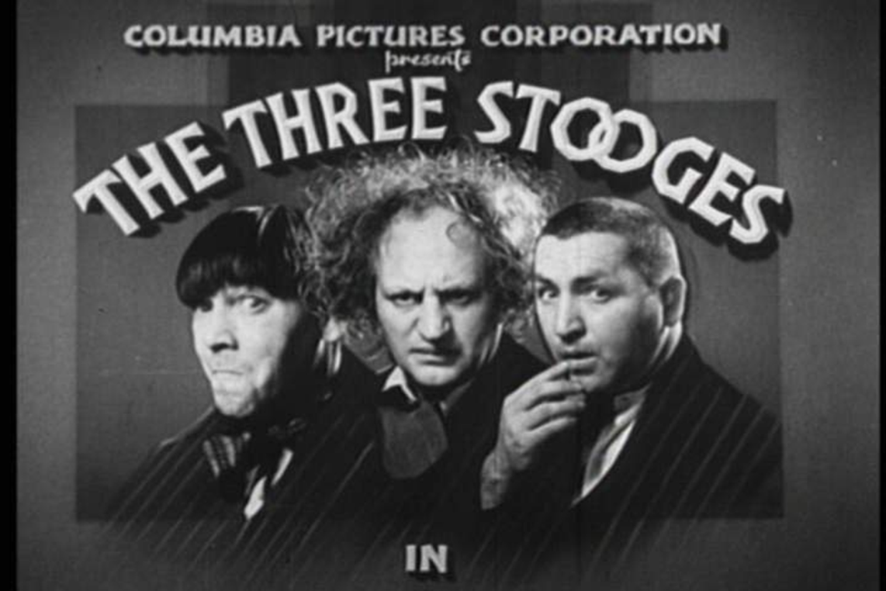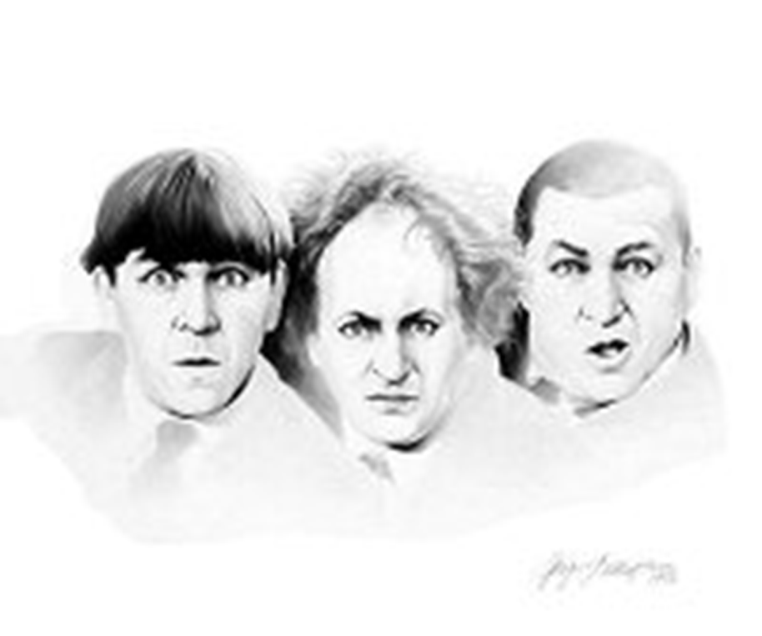

In In re NCAA Student–Athlete Name & Likeness Licensing Litigation, Judge Thomas issued a strong dissent from Judge Bybee’s majority opinion. Which opinion do you find to be more persuasive, the majority or the dissent?

In re NCAA Student–Athlete Name & Likeness Licensing Litigation
724 F.3d 1268 (9th Cir. 2013)
BYBEE, Circuit Judge:
[1] Video games are entitled to the full protections of the First Amendment, because “[l]ike the protected books, plays, and movies that preceded them, video games communicate ideas—and even social messages—through many familiar literary devices (such as characters, dialogue, plot, and music) and through features distinctive to the medium (such as the player's interaction with the virtual world).” Brown v. Entm't Merchs. Ass'n, ––– U.S. ––––, 131 S.Ct. 2729 (2011). Such rights are not absolute, and states may recognize the right of publicity to a degree consistent with the First Amendment. Zacchini v. Scripps–Howard Broad. Co., 433 U.S. 562, 574–75, 97 S.Ct. 2849, 53 L.Ed.2d 965 (1977). In this case, we must balance the right of publicity of a former college football player against the asserted First Amendment right of a video game developer to use his likeness in its expressive works.
[2] The district court concluded that the game developer, Electronic Arts (“EA”), had no First Amendment defense against the right-of-publicity claims of the football player, Samuel Keller. We affirm. Under the “transformative use” test developed by the California Supreme Court, EA's use does not qualify for First Amendment protection as a matter of law because it literally recreates Keller in the very setting in which he has achieved renown. The other First Amendment defenses asserted by EA do not defeat Keller's claims either.
I
[3] Samuel Keller was the starting quarterback for Arizona State University in 2005 before he transferred to the University of Nebraska, where he played during the 2007 season. EA is the producer of the NCAA Football series of video games, which allow users to control avatars representing college football players as those avatars participate in simulated games. In NCAA Football, EA seeks to replicate each school's entire team as accurately as possible. Every real football player on each team included in the game has a corresponding avatar in the game with the player's actual jersey number and virtually identical height, weight, build, skin tone, hair color, and home state. EA attempts to match any unique, highly identifiable playing behaviors by sending detailed questionnaires to team equipment managers. Additionally, EA creates realistic virtual versions of actual stadiums; populates them with the virtual athletes, coaches, cheerleaders, and fans realistically rendered by EA's graphic artists; and incorporates realistic sounds such as the crunch of the players' pads and the roar of the crowd.
[4] EA's game differs from reality in that EA omits the players' names on their jerseys and assigns each player a home town that is different from the actual player's home town. However, users of the video game may upload rosters of names obtained from third parties so that the names do appear on the jerseys. In such cases, EA allows images from the game containing athletes' real names to be posted on its website by users. Users can further alter reality by entering “Dynasty” mode, where the user assumes a head coach's responsibilities for a college program for up to thirty seasons, including recruiting players from a randomly generated pool of high school athletes, or “Campus Legend” mode, where the user controls a virtual player from high school through college, making choices relating to practices, academics, and social life.
[5] In the 2005 edition of the game, the virtual starting quarterback for Arizona State wears number 9, as did Keller, and has the same height, weight, skin tone, hair color, hair style, handedness, home state, play style (pocket passer), visor preference, facial features, and school year as Keller. In the 2008 edition, the virtual quarterback for Nebraska has these same characteristics, though the jersey number does not match, presumably because Keller changed his number right before the season started.
[6] Objecting to this use of his likeness, Keller filed a putative class-action complaint in the Northern District of California asserting, as relevant on appeal, that EA violated his right of publicity under California Civil Code § 3344 and California common law. EA moved to strike the complaint as a strategic lawsuit against public participation (“SLAPP”) under California's anti-SLAPP statute, Cal.Civ.Proc.Code § 425.16, and the district court denied the motion. We have jurisdiction over EA's appeal pursuant to 28 U.S.C. § 1291. See Batzel v. Smith, 333 F.3d 1018, 1024–26 (9th Cir.2003).
II
[7] California's anti-SLAPP statute is designed to discourage suits that “masquerade as ordinary lawsuits but are brought to deter common citizens from exercising their political or legal rights or to punish them for doing so.” Batzel, 333 F.3d at 1024 (internal quotation marks omitted). The statute provides:
A cause of action against a person arising from any act of that person in furtherance of the person's right of petition or free speech under the United States Constitution or the California Constitution in connection with a public issue shall be subject to a special motion to strike, unless the court determines that the plaintiff has established that there is a probability that the plaintiff will prevail on the claim.
Cal.Civ.Proc.Code § 425.16(b)(1). We have determined that the anti-SLAPP statute is available in federal court. Thomas v. Fry's Elecs., Inc., 400 F.3d 1206 (9th Cir.2005) (per curiam).
[8] We evaluate an anti-SLAPP motion in two steps. First, the defendant must “make a prima facie showing that the plaintiff's suit arises from an act by the defendant made in connection with a public issue in furtherance of the defendant's right to free speech under the United States or California Constitution.” Batzel, 333 F.3d at 1024. Keller does not contest that EA has made this threshold showing. Indeed, there is no question that “video games qualify for First Amendment protection,” Entm't Merchs. Ass'n, 131 S.Ct. at 2733, or that Keller's suit arises from EA's production and distribution of NCAA Football in furtherance of EA's protected right to express itself through video games.
[9] Second, we must evaluate whether the plaintiff has “establish[ed] a reasonable probability that the plaintiff will prevail on his or her ... claim.” Batzel, 333 F.3d at 1024. “The plaintiff must demonstrate that the complaint is legally sufficient and supported by a prima facie showing of facts to sustain a favorable judgment if the evidence submitted by plaintiff is credited.” Metabolife Int'l, Inc. v. Wornick, 264 F.3d 832, 840 (9th Cir.2001) (internal quotation marks omitted). The statute “subjects to potential dismissal only those actions in which the plaintiff cannot state and substantiate a legally sufficient claim.” Navellier v. Sletten, 29 Cal.4th 82, 124 Cal.Rptr.2d 530, 52 P.3d 703, 711 (2002) (internal quotation marks omitted). EA did not contest before the district court and does not contest here that Keller has stated a right-of-publicity claim under California common and statutory law. Instead, EA raises four affirmative defenses derived from the First Amendment: the “transformative use” test, the Rogers test, the “public interest” test, and the “public affairs” exemption. EA argues that, in light of these defenses, it is not reasonably probable that Keller will prevail on his right-of-publicity claim. This appeal therefore centers on the applicability of these defenses. We take each one in turn.
A
[10] The California Supreme Court formulated the transformative use defense in Comedy III Productions, Inc. v. Gary Saderup, Inc., 25 Cal.4th 387, 106 Cal.Rptr.2d 126, 21 P.3d 797 (2001). The defense is “a balancing test between the First Amendment and the right of publicity based on whether the work in question adds significant creative elements so as to be transformed into something more than a mere celebrity likeness or imitation.” Id. 106 Cal.Rptr.2d 126, 21 P.3d at 799. The California Supreme Court explained that “when a work contains significant transformative elements, it is not only especially worthy of First Amendment protection, but it is also less likely to interfere with the economic interest protected by the right of publicity.” Id. 106 Cal.Rptr.2d 126, 21 P.3d at 808. The court rejected the wholesale importation of the copyright “fair use” defense into right-of-publicity claims, but recognized that some aspects of that defense are “particularly pertinent.” Id.; see 17 U.S.C. § 107; see also SOFA Entm't, Inc. v. Dodger Prods., Inc., 709 F.3d 1273, 1277–78 (9th Cir.2013) (discussing the “fair use” defense codified in 17 U.S.C. § 107).
[11] Comedy III gives us at least five factors to consider in determining whether a work is sufficiently transformative to obtain First Amendment protection. See J. Thomas McCarthy, The Rights of Publicity and Privacy § 8:72 (2d ed.2012). First, if “the celebrity likeness is one of the ‘raw materials' from which an original work is synthesized,” it is more likely to be transformative than if “the depiction or imitation of the celebrity is the very sum and substance of the work in question.” Comedy III, 106 Cal.Rptr.2d 126, 21 P.3d at 809. Second, the work is protected if it is “primarily the defendant's own expression”—as long as that expression is “something other than the likeness of the celebrity.” Id. This factor requires an examination of whether a likely purchaser's primary motivation is to buy a reproduction of the celebrity, or to buy the expressive work of that artist. McCarthy, supra, § 8:72. Third, to avoid making judgments concerning “the quality of the artistic contribution,” a court should conduct an inquiry “more quantitative than qualitative” and ask “whether the literal and imitative or the creative elements predominate in the work.” Comedy III, 106 Cal.Rptr.2d 126, 21 P.3d at 809. Fourth, the California Supreme Court indicated that “a subsidiary inquiry” would be useful in close cases: whether “the marketability and economic value of the challenged work derive primarily from the fame of the celebrity depicted.” Id. 106 Cal.Rptr.2d 126, 21 P.3d at 810. Lastly, the court indicated that “when an artist's skill and talent is manifestly subordinated to the overall goal of creating a conventional portrait of a celebrity so as to commercially exploit his or her fame,” the work is not transformative. Id.
[12] We have explained that “[o]nly if [a defendant] is entitled to the [transformative] defense as a matter of law can it prevail on its motion to strike,” because the California Supreme Court “envisioned the application of the defense as a question of fact.” Hilton, 599 F.3d at 910. As a result, EA “is only entitled to the defense as a matter of law if no trier of fact could reasonably conclude that the [game] [i]s not transformative.” Id.
[13] California courts have applied the transformative use test in relevant situations in four cases. First, in Comedy III itself, the California Supreme Court applied the test to T-shirts and lithographs bearing a likeness of The Three Stooges and concluded that it could “discern no significant transformative or creative contribution.” Id. 106 Cal.Rptr.2d 126, 21 P.3d at 811. The court reasoned that the artist's “undeniable skill is manifestly subordinated to the overall goal of creating literal, conventional depictions of The Three Stooges so as to exploit their fame.” Id. “[W]ere we to decide that [the artist's] depictions were protected by the First Amendment,” the court continued, “we cannot perceive how the right of publicity would remain a viable right other than in cases of falsified celebrity endorsements.” Id.
[14] Second, in Winter v. DC Comics, the California Supreme Court applied the test to comic books containing characters Johnny and Edgar Autumn, “depicted as villainous half-worm, half-human offspring” but evoking two famous brothers, rockers Johnny and Edgar Winter. 30 Cal.4th 881, 134 Cal.Rptr.2d 634, 69 P.3d 473, 476 (2003). [See relevant images below]. The court held that “the comic books are transformative and entitled to First Amendment protection.” Id. 134 Cal.Rptr.2d 634, 69 P.3d at 480. It reasoned that the comic books “are not just conventional depictions of plaintiffs but contain significant expressive content other than plaintiffs' mere likenesses.” Id. 134 Cal.Rptr.2d 634, 69 P.3d at 479. “To the extent the drawings of the Autumn brothers resemble plaintiffs at all, they are distorted for purposes of lampoon, parody, or caricature.” Id. Importantly, the court relied on the fact that the brothers “are but cartoon characters ... in a larger story, which is itself quite expressive.” Id.
[15] Third, in Kirby v. Sega of America, Inc., the California Court of Appeal applied the transformative use test to a video game in which the user controls the dancing of “Ulala,” a reporter from outer space allegedly based on singer Kierin Kirby, whose “‘signature’ lyrical expression ... is ‘ooh la la.’” 144 Cal.App.4th 47, 50 Cal.Rptr.3d 607, 609–10 (2006). [See relevant images below]. The court held that “Ulala is more than a mere likeness or literal depiction of Kirby,” pointing to Ulala's “extremely tall, slender computer-generated physique,” her “hairstyle and primary costume,” her dance moves, and her role as “a space-age reporter in the 25th century,” all of which were “unlike any public depiction of Kirby.” Id. at 616. “As in Winter, Ulala is a ‘fanciful, creative character’ who exists in the context of a unique and expressive video game.” Id. at 618.
[16] Finally, in No Doubt v. Activision Publishing, Inc., the California Court of Appeal addressed Activision's Band Hero video game. 192 Cal.App.4th 1018, 122 Cal.Rptr.3d 397, 400 (2011), petition for review denied, 2011 Cal. LEXIS 6100 (Cal. June 8, 2011) (No. B223996). [See relevant images below]. In Band Hero, users simulate performing in a rock band in time with popular songs. Id. at 401. Users choose from a number of avatars, some of which represent actual rock stars, including the members of the rock band No Doubt. Id. at 401. Activision licensed No Doubt's likeness, but allegedly exceeded the scope of the license by permitting users to manipulate the No Doubt avatars to play any song in the game, solo or with members of other bands, and even to alter the avatars' voices. Id. at 402. The court held that No Doubt's right of publicity prevailed despite Activision's First Amendment defense because the game was not “transformative” under the Comedy III test. It reasoned that the video game characters were “literal recreations of the band members,” doing “the same activity by which the band achieved and maintains its fame.” Id. at 411. According to the court, the fact “that the avatars appear in the context of a videogame that contains many other creative elements[ ] does not transform the avatars into anything other than exact depictions of No Doubt's members doing exactly what they do as celebrities.” Id. The court concluded that “the expressive elements of the game remain manifestly subordinated to the overall goal of creating a conventional portrait of No Doubt so as to commercially exploit its fame.” Id. (internal quotation marks omitted).
[17] We have also had occasion to apply the transformative use test. In Hilton v. Hallmark Cards, we applied the test to a birthday card depicting Paris Hilton in a manner reminiscent of an episode of Hilton's reality show The Simple Life. 599 F.3d at 899. [See relevant image below]. We observed some differences between the episode and the card, but noted that “the basic setting is the same: we see Paris Hilton, born to privilege, working as a waitress.” Id. at 911. We reasoned that “[w]hen we compare Hallmark's card to the video game in Kirby, which transported a 1990s singer (catchphrases and all) into the 25th century and transmogrified her into a space-age reporter, ... the card falls far short of the level of new expression added in the video game.” Id. As a result, we concluded that “there is enough doubt as to whether Hallmark's card is transformative under our case law that we cannot say Hallmark is entitled to the defense as a matter of law.” Id.
[18] With these cases in mind as guidance, we conclude that EA's use of Keller's likeness does not contain significant transformative elements such that EA is entitled to the defense as a matter of law. The facts of No Doubt are very similar to those here. EA is alleged to have replicated Keller's physical characteristics in NCAA Football, just as the members of No Doubt are realistically portrayed in Band Hero. Here, as in Band Hero, users manipulate the characters in the performance of the same activity for which they are known in real life—playing football in this case, and performing in a rock band in Band Hero. The context in which the activity occurs is also similarly realistic—real venues in Band Hero and realistic depictions of actual football stadiums in NCAA Football. As the district court found, Keller is represented as “what he was: the starting quarterback for Arizona State” and Nebraska, and “the game's setting is identical to where the public found [Keller] during his collegiate career: on the football field.” Keller v. Elec. Arts, Inc., No. C 09–1967 CW, 2010 WL 530108, at *5 (N.D.Cal. Feb. 8, 2010).
[19] EA argues that the district court erred in focusing primarily on Keller's likeness and ignoring the transformative elements of the game as a whole. Judge Thomas, our dissenting colleague, suggests the same. See Dissent at 1285. We are unable to say that there was any error, particularly in light of No Doubt, which reasoned much the same as the district court in this case: “that the avatars appear in the context of a videogame that contains many other creative elements[ ] does not transform the avatars into anything other than exact depictions of No Doubt's members doing exactly what they do as celebrities.” No Doubt, 122 Cal.Rptr.3d at 411. EA suggests that the fact that NCAA Football users can alter the characteristics of the avatars in the game is significant. Again, our dissenting colleague agrees. See Dissent at 1286–87. In No Doubt, the California Court of Appeal noted that Band Hero “d[id] not permit players to alter the No Doubt avatars in any respect.” Id. at 410. The court went on to say that the No Doubt avatars “remain at all times immutable images of the real celebrity musicians, in stark contrast to the ‘fanciful, creative characters' in Winter and Kirby.” Id. The court explained further:
[I]t is the differences between Kirby and the instant case ... which are determinative. In Kirby, the pop singer was portrayed as an entirely new character—the space-age news reporter Ulala. In Band Hero, by contrast, no matter what else occurs in the game during the depiction of the No Doubt avatars, the avatars perform rock songs, the same activity by which the band achieved and maintains its fame. Moreover, the avatars perform those songs as literal recreations of the band members. That the avatars can be manipulated to perform at fanciful venues including outer space or to sing songs the real band would object to singing, or that the avatars appear in the context of a videogame that contains many other creative elements, does not transform the avatars into anything other than exact depictions of No Doubt's members doing exactly what they do as celebrities.
Id. at 410–11. Judge Thomas says that “[t]he Court of Appeal cited character immutability as a chief factor distinguishing [No Doubt ] from Winter and Kirby.” Dissent at 1287. Though No Doubt certainly mentioned the immutability of the avatars, we do not read the California Court of Appeal's decision as turning on the inability of users to alter the avatars. The key contrast with Winter and Kirby was that in those games the public figures were transformed into “fanciful, creative characters” or “portrayed as ... entirely new character[s].” No Doubt, 122 Cal.Rptr.3d at 410. On this front, our case is clearly aligned with No Doubt, not with Winter and Kirby. We believe No Doubt offers a persuasive precedent that cannot be materially distinguished from Keller's case.,
[20] The Third Circuit came to the same conclusion in Hart v. Electronic Arts, Inc., 717 F. 3d 141 ( 3d Cir. 2013). In Hart, EA faced a materially identical challenge under New Jersey right-of-publicity law, brought by former Rutgers quarterback Ryan Hart. See id. at 163 n. 28 (“Keller is simply [Hart ] incarnated in California.”). Though the Third Circuit was tasked with interpreting New Jersey law, the court looked to the transformative use test developed in California. See id. at 158 n. 23 (noting that the right-of-publicity laws are “strikingly similar ... and protect similar interests” in New Jersey and California, and that “consequently [ there is] no issue in applying balancing tests developed in California to New Jersey”); see also id. at 165 (holding that “the Transformative Use Test is the proper analytical framework to apply to cases such as the one at bar”). Applying the test, the court held that “the NCAA Football ... games at issue ... do not sufficiently transform [ Hart]'s identity to escape the right of publicity claim,” reversing the district court's grant of summary judgment to EA. Id. at 170.
[21] As we have, the Third Circuit considered the potentially transformative nature of the game as a whole, id. at 166, 169, and the user's ability to alter avatar characteristics, id. at 166– 68. Asserting that “the lack of transformative context is even more pronounced here than in No Doubt,” id. at 166, and that “the ability to modify the avatar counts for little where the appeal of the game lies in users' ability to play as, or alongside [,] their preferred players or team,” id. at 168 (internal quotation marks omitted), the Third Circuit agreed with us that these changes do not render the NCAA Football games sufficiently transformative to defeat a right-of-publicity claim.
[22] Judge Ambro dissented in Hart, concluding that “the creative components of NCAA Football contain sufficient expressive transformation to merit First Amendment protection.” Id. at 175 (Ambro, J., dissenting). But in critiquing the majority opinion, Judge Ambro disregarded No Doubt and Kirby because “they were not decided by the architect of the Transformative Use Test, the Supreme Court of California.” Id. at 172 n. 4. He thus “d [id] not attempt to explain or distinguish the[se cases'] holdings except to note that [he] believe[s] No Doubt, which focused on individual depictions rather than the work in its entirety, was wrongly decided in light of the prior precedent in Comedy III and Winter.” Id. We recognize that we are bound only by the decisions of a state's highest court and not by decisions of the state's intermediate appellate court when considering state law issues sitting in diversity jurisdiction. See In re Kirkland, 915 F.2d 1236, 1238–39 (9th Cir.1990). Nonetheless, where there is no binding precedent from the state's highest court, we “must predict how the highest state court would decide the issue using intermediate appellate court decisions, decisions from other jurisdictions, statutes, treatises, and restatements as guidance.” Id. at 1239 (emphasis added). As stated above, we believe No Doubt in particular provides persuasive guidance. We do not believe No Doubt to be inconsistent with the California Supreme Court's relevant decisions, and we will not disregard a well-reasoned decision from a state's intermediate appellate court in this context. Like the majority in Hart, we rely substantially on No Doubt, and believe we are correct to do so.
[23] Given that NCAA Football realistically portrays college football players in the context of college football games, the district court was correct in concluding that EA cannot prevail as a matter of law based on the transformative use defense at the anti-SLAPP stage. Cf. Hilton, 599 F.3d at 910–11.
B
[24] EA urges us to adopt for right-of-publicity claims the broader First Amendment defense that we have previously adopted in the context of false endorsement claims under the Lanham Act: the Rogers test. See Brown v. Elec. Arts, 724 F.3d at 1239–41, 2013 WL 3927736, at *1–2 (applying the Rogers test to a Lanham Act claim brought by former NFL player Jim Brown relating to the use of his likeness in EA's Madden NFL video games).
[25] Rogers v. Grimaldi is a landmark Second Circuit case balancing First Amendment rights against claims under the Lanham Act. 875 F.2d 994 (2d Cir.1989). The case involved a suit brought by the famous performer Ginger Rogers against the producers and distributors of Ginger and Fred, a movie about two fictional Italian cabaret performers who imitated Rogers and her frequent performing partner Fred Astaire. Id. at 996–97. Rogers alleged both a violation of the Lanham Act for creating the false impression that she endorsed the film and infringement of her common law right of publicity. Id. at 997.
[26] The Rogers court recognized that “[m]ovies, plays, books, and songs are all indisputably works of artistic expression and deserve protection,” but that “[t]he purchaser of a book, like the purchaser of a can of peas, has a right not to be misled as to the source of the product.” Id. “Consumers of artistic works thus have a dual interest: They have an interest in not being misled and they also have an interest in enjoying the results of the author's freedom of expression.” Id. at 998. The Rogers court determined that titles of artistic or literary works were less likely to be misleading than “the names of ordinary commercial products,” and thus that Lanham Act protections applied with less rigor when considering titles of artistic or literary works than when considering ordinary products. Id. at 999–1000. The court concluded that “in general the Act should be construed to apply to artistic works only where the public interest in avoiding consumer confusion outweighs the public interest in free expression.” Id. at 999. The court therefore held:
In the context of allegedly misleading titles using a celebrity's name, that balance will normally not support application of the [Lanham] Act unless the title has no artistic relevance to the underlying work whatsoever, or, if it has some artistic relevance, unless the title explicitly misleads as to the source or the content of the work.
Id.
[27] We first endorsed the Rogers test for Lanham Act claims involving artistic or expressive works in Mattel, Inc. v. MCA Records, Inc., 296 F.3d 894, 902 (9th Cir.2002). We agreed that, in the context of artistic and literary titles, “[c]onsumers expect a title to communicate a message about the book or movie, but they do not expect it to identify the publisher or producer,” and “adopt[ed] the Rogers standard as our own.” Id. Then, in E.S.S. Entertainment 2000, Inc. v. Rock Star Videos, Inc., we considered a claim by a strip club owner that video game maker Rock Star incorporated its club logo into the game's virtual depiction of East Los Angeles, violating the club's trademark right to that logo. 547 F.3d 1095, 1096–98 (9th Cir.2008). We held that Rock Star's use of the logo and trade dress was protected by the First Amendment and that it therefore could not be held liable under the Lanham Act. Id. at 1099–1101. In so doing, we extended the Rogers test slightly, noting that “[a]lthough this test traditionally applies to uses of a trademark in the title of an artistic work, there is no principled reason why it ought not also apply to the use of a trademark in the body of the work.” Id. at 1099.
[28] In this case, EA argues that we should extend this test, created to evaluate Lanham Act claims, to apply to right-of-publicity claims because it is “less prone to misinterpretation” and “more protective of free expression” than the transformative use defense. Although we acknowledge that there is some overlap between the transformative use test formulated by the California Supreme Court and the Rogers test, we disagree that the Rogers test should be imported wholesale for right-of-publicity claims. Our conclusion on this point is consistent with the Third Circuit's rejection of EA's identical argument in Hart. See Hart, 717 F. 3d at 154– 58. As the history and development of the Rogers test makes clear, it was designed to protect consumers from the risk of consumer confusion—the hallmark element of a Lanham Act claim. See Cairns v. Franklin Mint Co., 292 F.3d 1139, 1149 (9th Cir.2002). The right of publicity, on the other hand, does not primarily seek to prevent consumer confusion. See Hart, 717 F. 3d at 158 (“[ T]he right of publicity does not implicate the potential for consumer confusion....”). Rather, it primarily “protects a form of intellectual property [in one's person] that society deems to have some social utility.” Comedy III, 106 Cal.Rptr.2d 126, 21 P.3d at 804. As the California Supreme Court has explained:
Often considerable money, time and energy are needed to develop one's prominence in a particular field. Years of labor may be required before one's skill, reputation, notoriety or virtues are sufficiently developed to permit an economic return through some medium of commercial promotion. For some, the investment may eventually create considerable commercial value in one's identity.
Id. 106 Cal.Rptr.2d 126, 21 P.3d at 804–05 (internal quotation marks and citations omitted).
[29] The right of publicity protects the celebrity, not the consumer. Keller's publicity claim is not founded on an allegation that consumers are being illegally misled into believing that he is endorsing EA or its products. Indeed, he would be hard-pressed to support such an allegation absent evidence that EA explicitly misled consumers into holding such a belief. See Brown v. Elec. Arts, 724 F.3d at 1242–43, 2013 WL 3927736, at *4 (holding under the Rogers test that, since “Brown's likeness is artistically relevant to the [Madden NFL ] games and there are no alleged facts to support the claim that EA explicitly misled consumers as to Brown's involvement with the games,” “the public interest in free expression outweighs the public interest in avoiding consumer confusion”). Instead, Keller's claim is that EA has appropriated, without permission and without providing compensation, his talent and years of hard work on the football field. The reasoning of the Rogers and Mattel courts—that artistic and literary works should be protected unless they explicitly mislead consumers—is simply not responsive to Keller's asserted interests here. Cf. Hart, 717 F. 3d at 157 (“Effectively, [EA] argues that [Hart] should be unable to assert a claim for appropriating his likeness as a football player precisely because his likeness was used for a game about football. Adopting this line of reasoning threatens to turn the right of publicity on its head.”).
[30] We recognize that Rogers also dealt with a right-of-publicity claim—one under Oregon law—and applied a modified version of its Lanham Act test in order to adapt to that particular context:
In light of the Oregon Court's concern for the protection of free expression, ... the right of publicity [would not] bar the use of a celebrity's name in a movie title unless the title was “wholly unrelated” to the movie or was “simply a disguised commercial advertisement for the sale of goods or services.”
875 F.2d at 1004. However, the Rogers court was faced with a situation in which the “Oregon Courts ... [had] not determined the scope of the common law right of publicity in that state.” Id. at 1002. In the absence of clear state-law precedent, the Rogers court was “obliged to engage in the uncertain task of predicting what the New York courts would predict the Oregon courts would rule as to the contours of a right of publicity under Oregon law.” Id. In light of Comedy III and its progeny, we are faced with no such uncertain task.
[31] Lastly, we note that the only circuit court to import the Rogers test into the publicity arena, the Sixth Circuit, has done so inconsistently. In Parks v. LaFace Records, the Sixth Circuit indicated that the Rogers test was appropriate for right-of-publicity claims, noting that the Restatement (Third) of Unfair Competition had endorsed use of the test in that context. 329 F.3d 437, 461 (6th Cir.2003) (citing Restatement (Third) of Unfair Competition § 47 cmt. c). Subsequently, in ETW Corp. v. Jireh Publishing, Inc., the court acknowledged the Parks decision but did not apply the Rogers test to the Ohio right-of-publicity claim in question. 332 F.3d at 915, 936 & n. 17 (6th Cir.2003). Instead, the court applied a balancing test from comment d in the Restatement (analyzing “the substantiality and market effect of the use of the celebrity's image ... in light of the informational and creative content”), as well as the transformative use test from Comedy III. Id. at 937–38; see Hart, 717 F. 3d at 157 (“We find Parks to be less than persuasive [as to the applicability of the Rogers test to right-of-publicity cases] given that just over a month later another panel of the Sixth Circuit decided [ETW ], a right of publicity case where the Circuit applied the Transformative Use Test.”). Similarly, the Tenth Circuit in Cardtoons, L.C. v. Major League Baseball Players Ass'n, 95 F.3d 959 (10th Cir.1996), and the Eighth Circuit in C.B.C. Distribution and Marketing, Inc. v. Major League Baseball Advanced Media, L.P., 505 F.3d 818 (8th Cir.2007), rejected the Rogers test in favor of a flexible case-by-case approach that takes into account the celebrity's interest in retaining his or her publicity and the public's interest in free expression. Therefore, we decline EA's invitation to extend the Rogers test to right-of-publicity claims.
C
[32] California has developed two additional defenses aimed at protecting the reporting of factual information under state law. One of these defenses only applies to common law right-of-publicity claims while the other only applies to statutory right-of-publicity claims. Montana v. San Jose Mercury News, Inc., 34 Cal.App.4th 790, 40 Cal.Rptr.2d 639, 640 (1995). Liability will not lie for common law right-of-publicity claims for the “publication of matters in the public interest.” Id. at 640–41. Similarly, liability will not lie for statutory right-of-publicity claims for the “use of a name, voice, signature, photograph, or likeness in connection with any news, public affairs, or sports broadcast or account, or any political campaign.” Cal. Civ.Code § 3344(d). Although these defenses are based on First Amendment concerns, Gill v. Hearst Publ'g Co., 40 Cal.2d 224, 253 P.2d 441, 443–44 (1953), they are not coextensive with the Federal Constitution, New Kids on the Block v. News Am. Publ'g, Inc., 971 F.2d 302, 310 n. 10 (9th Cir.1992), and their application is thus a matter of state law.
[33] EA argues that these defenses give it the right to “incorporate athletes' names, statistics, and other biographical information” into its expressive works, as the defenses were “designed to create ‘extra breathing space’ for the use of a person's name in connection with matters of public interest.” Keller responds that the right of publicity yields to free use of a public figure's likeness only to the extent reasonably required to report information to the public or publish factual data, and that the defenses apply only to broadcasts or accounts of public affairs, not to EA's NCAA Football games, which do not contain or constitute such reporting about Keller.
[34] California courts have generally analyzed the common law defense and the statutory defense separately, but it is clear that both defenses protect only the act of publishing or reporting. By its terms, § 3344(d) is limited to a “broadcast or account,” and we have confirmed that the common law defense is about a publication or reporting of newsworthy items. Hilton, 599 F.3d at 912. However, most of the discussion by California courts pertains to whether the subject matter of the communication is of “public interest” or related to “news” or “public affairs,” leaving little guidance as to when the communication constitutes a publication or reporting.
[35] For instance, in Dora v. Frontline Video, Inc., a wellknown surfer sued the producer of a documentary on surfing entitled “The Legends of Malibu,” claiming misappropriation of his name and likeness. 15 Cal.App.4th 536, 18 Cal.Rptr.2d 790, 791 (1993). The court held that the documentary was protected because it was “a fair comment on real life events which have caught the popular imagination.” Id. at 792 (internal quotation marks omitted). The court explained that surfing “has created a lifestyle that influences speech, behavior, dress, and entertainment,” has had “an economic impact,” and “has also had a significant influence on the popular culture,” such that “[i]t would be difficult to conclude that a surfing documentary does not fall within the category of public affairs.” Id. at 794–95. Similarly, in Gionfriddo v. Major League Baseball, retired professional baseball players alleged that Major League Baseball violated their right of publicity by displaying “factual data concerning the players, their performance statistics, and verbal descriptions and video depictions of their play” in game programs and on its website. 94 Cal.App.4th 400, 114 Cal.Rptr.2d 307, 314 (2001). The court reasoned that “[t]he recitation and discussion of factual data concerning the athletic performance of these plaintiffs command a substantial public interest, and, therefore, is a form of expression due substantial constitutional protection.” Id. at 315. And in Montana v. San Jose Mercury News, Inc., former NFL quarterback Joe Montana brought a right-of-publicity action against a newspaper for selling posters containing previously published pages from the newspaper depicting the many Super Bowl victories by Montana and the San Francisco 49ers. Montana, 40 Cal.Rptr.2d at 639–40. The court found that “[p]osters portraying the 49'ers' [sic] victories are ... a form of public interest presentation to which protection must be extended.” Id. at 641 (internal quotation marks omitted).
[36] We think that, unlike in Gionfriddo, Montana, and Dora, EA is not publishing or reporting factual data. EA's video game is a means by which users can play their own virtual football games, not a means for obtaining information about real-world football games. Although EA has incorporated certain actual player information into the game (height, weight, etc.), its case is considerably weakened by its decision not to include the athletes' names along with their likenesses and statistical data. EA can hardly be considered to be “reporting” on Keller's career at Arizona State and Nebraska when it is not even using Keller's name in connection with his avatar in the game. Put simply, EA's interactive game is not a publication of facts about college football; it is a game, not a reference source. These state law defenses, therefore, do not apply.
III
[37] Under California's transformative use defense, EA's use of the likenesses of college athletes like Samuel Keller in its video games is not, as a matter of law, protected by the First Amendment. We reject EA's suggestion to import the Rogers test into the right-of-publicity arena, and conclude that state law defenses for the reporting of information do not protect EA's use.
AFFIRMED.

THOMAS, Circuit Judge, dissenting:
[1] Because the creative and transformative elements of Electronic Arts' NCAA Football video game series predominate over the commercial use of the athletes' likenesses, the First Amendment protects EA from liability. Therefore, I respectfully dissent.
I
[2] As expressive works, video games are entitled to First Amendment protection. Brown v. Entm't Merchs. Ass'n, ––– U.S. ––––, 131 S.Ct. 2729 (2011). The First Amendment affords additional protection to NCAA Football because it involves a subject of substantial public interest: collegiate football. Moore v. Univ. of Notre Dame, 968 F.Supp. 1330, 1337 (N.D.Ind.1997). Because football is a matter of public interest, the use of the images of athletes is entitled to constitutional protection, even if profits are involved. Montana v. San Jose Mercury News, Inc., 34 Cal.App.4th 790, 40 Cal.Rptr.2d 639, 643 n. 2 (1995); see also Cal. Civ.Code § 3344(d) (exempting from liability the “use of a name ... or likeness in connection with any ... public affairs, or sports broadcast or account”).
[3] Where it is recognized, the tort of appropriation is a creature of common law or statute, depending on the jurisdiction. However, the right to compensation for the misappropriation for commercial use of one's image or celebrity is far from absolute. In every jurisdiction, any right of publicity must be balanced against the constitutional protection afforded by the First Amendment. Courts have employed a variety of methods in balancing the rights. See, e.g., Doe v. TCI Cablevision, 110 S.W.3d 363, 374 (Mo.2003) (en banc). The California Supreme Court applies a “transformative use” test it formulated in Comedy III Productions, Inc. v. Gary Saderup, Inc., 25 Cal.4th 387, 106 Cal.Rptr.2d 126, 21 P.3d 797 (2001).
[4] As the majority properly notes, the transformative use defense is “a balancing test between the First Amendment and the right of publicity based on whether the work in question adds significant creative elements so as to be transformed into something more than a mere celebrity likeness or imitation.” Comedy III, 106 Cal.Rptr.2d 126, 21 P.3d at 799. The rationale for the test, as the majority notes, is that “when a work contains significant transformative elements, it is not only especially worthy of First Amendment protection, but it is also less likely to interfere with the economic interest protected by the right of publicity.” Id. 106 Cal.Rptr.2d 126, 21 P.3d at 808.
[5] The five considerations articulated in Comedy III, and cited by the majority, are whether: (1) the celebrity likeness is one of the raw materials from which an original work is synthesized; (2) the work is primarily the defendant's own expression if the expression is something other than the likeness of the celebrity; (3) the literal and imitative or creative elements predominate in the work; (4) the marketability and economic value of the challenged work derives primarily from the fame of the celebrity depicted; and (5) an artist's skill and talent has been manifestly subordinated to the overall goal of creating a conventional portrait of a celebrity so as to commercially exploit the celebrity's fame. Id. 106 Cal.Rptr.2d 126, 21 P.3d at 809–10.
[6] Although these considerations are often distilled as analytical factors, Justice Mosk was careful in Comedy III not to label them as such. Indeed, the focus of Comedy III is a more holistic examination of whether the transformative and creative elements of a particular work predominate over commercially based literal or imitative depictions. The distinction is critical, because excessive deconstruction of Comedy III can lead to misapplication of the test. And it is at this juncture that I must respectfully part ways with my colleagues in the majority.
[7] The majority confines its inquiry to how a single athlete's likeness is represented in the video game, rather than examining the transformative and creative elements in the video game as a whole. In my view, this approach contradicts the holistic analysis required by the transformative use test. See Hart v. Elec. Arts, Inc., 717 F. 3d 141, 170– 76 ( 3d Cir. 2013) (Ambro, J., dissenting). The salient question is whether the entire work is transformative, and whether the transformative elements predominate, rather than whether an individual persona or image has been altered.
[8] When EA's NCAA Football video game series is examined carefully, and put in proper context, I conclude that the creative and transformative elements of the games predominate over the commercial use of the likenesses of the athletes within the games.
A
[9] The first step in conducting a balancing is to examine the creative work at issue. At its essence, EA's NCAA Football is a work of interactive historical fiction. Although the game changes from year to year, its most popular features predominately involve role-playing by the gamer. For example, a player can create a virtual image of himself as a potential college football player. The virtual player decides which position he would like to play, then participates in a series of “tryouts” or competes in an entire high school season to gauge his skill. Based on his performance, the virtual player is ranked and available to play at select colleges. The player chooses among the colleges, then assumes the role of a college football player. He also selects a major, the amount of time he wishes to spend on social activities, and practice—all of which may affect the virtual player's performance. He then plays his position on the college team. In some versions of the game, in another mode, the virtual player can engage in a competition for the Heisman Trophy. In another popular mode, the gamer becomes a virtual coach. The coach scouts, recruits, and develops entirely fictional players for his team. The coach can then promote the team's evolution over decades of seasons.
[10] The college teams that are supplied in the game do replicate the actual college teams for that season, including virtual athletes who bear the statistical and physical dimensions of the actual college athletes. But, unlike their professional football counterparts in the Madden NFL series, the NCAA football players in these games are not identified.
[11] The gamers can also change their abilities, appearances, and physical characteristics at will. Keller's impressive physical likeness can be morphed by the gamer into an overweight and slow virtual athlete, with anemic passing ability. And the gamer can create new virtual players out of whole cloth. Players can change teams. The gamer could pit Sam Keller against himself, or a stronger or weaker version of himself, on a different team. Or the gamer could play the game endlessly without ever encountering Keller's avatar. In the simulated games, the gamer controls not only the conduct of the game, but the weather, crowd noise, mascots, and other environmental factors. Of course, one may play the game leaving the players unaltered, pitting team against team. But, in this context as well, the work is one of historic fiction. The gamer controls the teams, players, and games.
[12] Applying the Comedy III considerations to NCAA Football in proper holistic context, the considerations favor First Amendment protection. The athletic likenesses are but one of the raw materials from which the broader game is constructed. The work, considered as a whole, is primarily one of EA's own expression. The creative and transformative elements predominate over the commercial use of likenesses. The marketability and economic value of the game comes from the creative elements within, not from the pure commercial exploitation of a celebrity image. The game is not a conventional portrait of a celebrity, but a work consisting of many creative and transformative elements.
[13] The video game at issue is much akin to the creations the California Supreme Court found protected in Winter v. DC Comics, 30 Cal.4th 881, 134 Cal.Rptr.2d 634, 69 P.3d 473, 476 (2003), where the two fabled guitarists Johnny and Edgar Winter were easily identifiable, but depicted as chimeras. It is also consistent with the California Court of Appeal's decision in Kirby v. Sega of America, Inc., 144 Cal.App.4th 47, 50 Cal.Rptr.3d 607, 609–10 (2006), where a character easily identified as singer Kierin Kirby, more popularly known as Lady Miss Kier, was transformed into a “‘fanciful, creative character’ who exists in the context of a unique and expressive video game.” Id. at 618. So, too, are the virtual players who populate the world of the NCAA Football series.
[14] No Doubt v. Activision Publishing, Inc., 192 Cal.App.4th 1018, 122 Cal.Rptr.3d 397 (2011), is not to the contrary. The literal representations in No Doubt were not, and could not be, transformed in any way. Indeed, in No Doubt, the bandmembers posed for motion-capture photography to allow reproduction of their likenesses, id. at 402, and the Court of Appeal underscored the fact that the video game did not “permit players to alter the No Doubt avatars in any respect” and the avatars remained “at all times immutable images of the real celebrity musicians,” id. at 410. The Court of Appeal cited character immutability as a chief factor distinguishing that case from Winter and Kirby. Id. Unlike the avatars in No Doubt, the virtual players in NCAA Football are completely mutable and changeable at the whim of the gamer. The majority places great reliance on No Doubt as support for its proposition that the initial placement of realistic avatars in the game overcomes the First Amendment's protection, but the Court of Appeal in No Doubt rejected such a cramped construction, noting that “even literal reproductions of celebrities may be ‘transformed’ into expressive works based on the context into which the celebrity image is placed.” Id. at 410 (citing Comedy III, 106 Cal.Rptr.2d 126, 21 P.3d at 797).
[15] Unlike the majority, I would not punish EA for the realism of its games and for the skill of the artists who created realistic settings for the football games. Majority op. at 1279 n. 10. That the lifelike roar of the crowd and the crunch of pads contribute to the gamer's experience demonstrates how little of NCAA Football is driven by the particular likeness of Sam Keller, or any of the other plaintiffs, rather than by the game's artistic elements.
[16] In short, considering the creative elements alone in this case satisfies the transformative use test in favor of First Amendment protection.
B
[17] Although one could leave the analysis with an examination of the transformative and creative aspects of the game, a true balancing requires an inquiry as to the other side of the scales: the publicity right at stake. Here, as well, the NCAA Football video game series can be distinguished from the traditional right of publicity cases, both from a quantitative and a qualitative perspective.
[18] As a quantitative matter, NCAA Football is different from other right of publicity cases in the sheer number of virtual actors involved. Most right of publicity cases involve either one celebrity, or a finite and defined group of celebrities. Comedy III involved literal likenesses of the Three Stooges. Hilton v. Hallmark Cards, 599 F.3d 894, 909–12 (9th Cir.2009), involved the literal likeness of Paris Hilton. Winter involved the images of the rock star brother duo. Kirby involved the likeness of one singer. No Doubt focused on the likenesses of the members of a specific legendary band.
[19] In contrast, NCAA Football includes not just Sam Keller, but thousands of virtual actors. This consideration is of particular significance when we examine, as instructed by Comedy III, whether the source of the product marketability comes from creative elements or from pure exploitation of a celebrity image. 106 Cal.Rptr.2d 126, 21 P.3d at 810. There is not, at this stage of the litigation, any evidence as to the personal marketing power of Sam Keller, as distinguished from the appeal of the creative aspects of the product. Regardless, the sheer number of athletes involved inevitably diminish the significance of the publicity right at issue. Comedy III involved literal depictions of the Three Stooges on lithographs and T-shirts. Winter involved characters depicted in a comic strip. Kirby and No Doubt involved pivotal characters in a video game. The commercial image of the celebrities in each case was central to the production, and its contact with the consumer was immediate and unavoidable. In contrast, one could play NCAA Football thousands of times without ever encountering a particular avatar. In context of the collective, an individual's publicity right is relatively insignificant. Put another way, if an anonymous virtual player is tackled in an imaginary video game and no one notices, is there any right of publicity infringed at all?
[20] The sheer quantity of the virtual players in the game underscores the inappropriateness of analyzing the right of publicity through the lens of one likeness only. Only when the creative work is considered in complete context can a proper analysis be conducted.
[21] As a qualitative matter, the essence of NCAA Football is founded on publicly available data, which is not protected by any individual publicity rights. It is true that EA solicits and receives information directly from colleges and universities. But the information is hardly proprietary. Personal vital statistics for players are found in college programs and media guides. Likewise, playing statistics are easily available. In this respect, the information used by EA is indistinguishable from the information used in fantasy athletic leagues, for which the First Amendment provides protection, C.B.C. Distribution & Mktg., Inc. v. Major League Baseball Advanced Media, L.P., 505 F.3d 818, 823–24 (8th Cir.2007), or much beloved statistical board games, such as Strat–O–Matic. An athlete's right of publicity simply does not encompass publicly available statistical data. See, e.g., IMS Health Inc. v. Sorrell, 630 F.3d 263, 271–72 (2d Cir.2010) (“The First Amendment protects ‘[e]ven dry information, devoid of advocacy, political relevance, or artistic expression.’” (quoting Universal City Studios, Inc. v. Corley, 273 F.3d 429, 446 (2d Cir.2001)) (alteration in original)).
[22] Further, the structure of the game is not founded on exploitation of an individual's publicity rights. The players are unidentified and anonymous. It is true that third-party software is available to quickly identify the players, but that is not part of the EA package. And the fact that the players can be identified by the knowledgeable user by their position, team, and statistics is somewhat beside the point. The issue is whether the marketability of the product is driven by an individual celebrity, or by the game itself. Comedy III, 106 Cal.Rptr.2d 126, 21 P.3d at 810. Player anonymity, while certainly not a complete defense, bears on the question of how we balance the right of publicity against the First Amendment. This feature of the game places it in stark contrast with No Doubt, where the whole point of the enterprise was the successful commercial exploitation of the specifically identified, world-famous musicians.
[23] Finally, as a qualitative matter, the publicity rights of college athletes are remarkably restricted. This consideration is critical because the “right to exploit commercially one's celebrity is primarily an economic right.” Gionfriddo v. Major League Baseball, 94 Cal.App.4th 400, 114 Cal.Rptr.2d 307, 318 (2001). NCAA rules prohibit athletes from benefitting economically from any success on the field. NCAA Bylaw 12.5 specifically prohibits commercial licensing of an NCAA athlete's name or picture. NCAA, 2012–13 NCAA Division I Manual § 12.5.2.1 (2012). Before being allowed to compete each year, all Division I NCAA athletes must sign a contract stating that they understand the prohibition on licensing and affirming that they have not violated any amateurism rules. In short, even if an athlete wished to license his image to EA, the athlete could not do so without destroying amateur status. Thus, an individual college athlete's right of publicity is extraordinarily circumscribed and, in practical reality, nonexistent.
[24] In sum, even apart from consideration of transformative elements, examination of the right of publicity in question also resolves the balance in favor of the First Amendment. The quantity of players involved dilutes the commercial impact of any particular player and the scope of the publicity right is significantly reduced by the fact that: (1) a player cannot own the individual, publicly available statistics on which the game is based; (2) the players are not identified in the game; and (3) NCAA college athletes do not have the right to license their names and likenesses, even if they chose to do so.
II
[25] Given the proper application of the transformative use test, Keller is unlikely to prevail. The balance of interests falls squarely on the side of the First Amendment. The stakes are not small. The logical consequence of the majority view is that all realistic depictions of actual persons, no matter how incidental, are protected by a state law right of publicity regardless of the creative context. This logic jeopardizes the creative use of historic figures in motion pictures, books, and sound recordings. Absent the use of actual footage, the motion picture Forrest Gump might as well be just a box of chocolates. Without its historical characters, Midnight in Paris would be reduced to a pedestrian domestic squabble. The majority's holding that creative use of realistic images and personas does not satisfy the transformative use test cannot be reconciled with the many cases affording such works First Amendment protection. I respectfully disagree with this potentially dangerous and out-of-context interpretation of the transformative use test.
[26] For these reasons, I respectfully dissent.
----------------------------------------------------

Winter v. DC Comics, 30 Cal.4th 881 (2003)

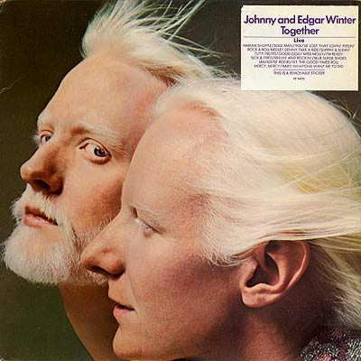
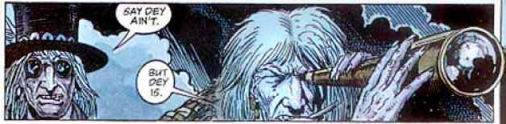

Kirby v. Sega of America, Inc., 144 Cal.App.4th 47 (2006)

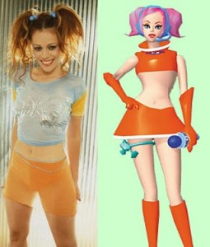

No Doubt v. Activision Publishing, Inc., 192 Cal.App.4th 1018 (2011)

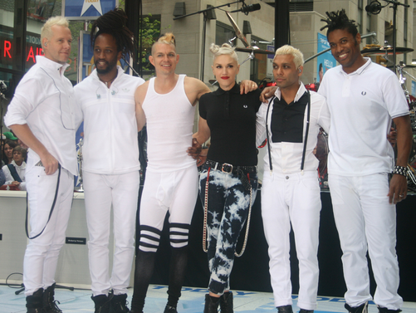



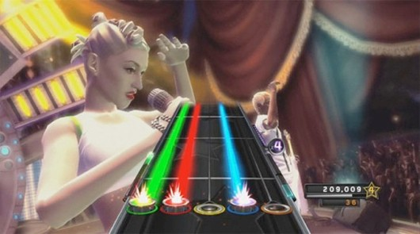

Hilton v. Hallmark Cards, 599 F.3d 894 (9th Cir. 2010)

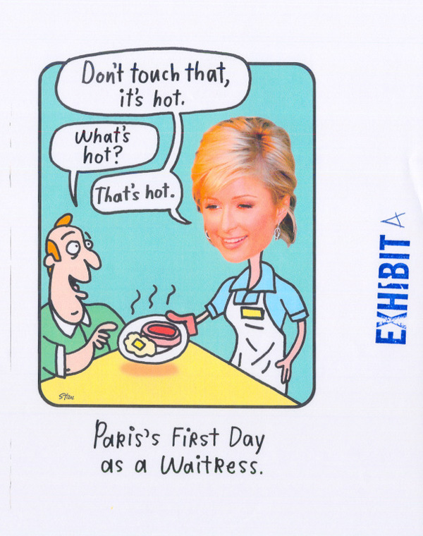
Comments and Questions
1. Keller Settlement. In June 2014, the NCAA announced a $20 million settlement with Samuel Keller, the lead plaintiff in In re NCAA Student-Athlete Name & Likeness Licensing Litigation. This is in addition to a previous $40 settlement Electronic Arts and Collegiate Licensing Company announced to settle a variety of lawsuits, including Keller’s, over use of collegiate athletes’ likenesses in video games. The total $60 million settlement fund will be distributed among approximately 75,000 potentially eligible NCAA football and male basketball athletes with a cap of $5,000 per roster appearance per video game, with many athletes receiving significantly less than this amount. See Jon Solomon, EA and NCAA Video Game Settlements Have a $5,000-a-Year Cap, CBSSports.com, June 30, 2014, http://www.cbssports.com/collegefootball/writer/jon-solomon/24601765/ea-and-ncaa-video-game-settlements-have-5000-a-year-cap.
2. The Fate of EA’s NCAA Football Series. In September 2013, EA announced that it would not produce a new NCAA Football video game in 2014, making NCAA Football 2014 the final instalment in the series. EA did so after the NCAA and three major football conferences (the Big Ten, Pac-12, and SEC) cut ties with EA in light of the college players’ intellectual property litigation against EA. See Steve Eder, E.A. Sports Settles Lawsuit With College Athletes, N.Y. Times, Sept. 26, 2013, http://www.nytimes.com/2013/09/27/sports/ncaafootball/ea-sports-wont-make-college-video-game-in-2014.html?_r=0.
3. Celebrities’ Right of Publicity and Social Media. In April 2014 American actress and celebrity Katherine Hegel sued the drugstore chain Duane Reade for posting the tweet and photograph shown below. She claimed violation of federal false advertising law under Lanham Act § 43(a), 15 U.S.C. § 1125(a), and New York state right of publicity law under N.Y. Civil Rights Law §§ 50 & 51. In August 2014, the parties announced a settlement in which Duane Reade agreed to make a contribution of an undisclosed amount to a Katherine Heigl charity. See Eriq Gardner, Katherine Heigl Ends Lawsuit Over Duane Reade Tweet, Hollywood Reporter, Aug. 27, 2014, http://www.hollywoodreporter.com/thr-esq/katherine-heigl-ends-lawsuit-duane-728552.
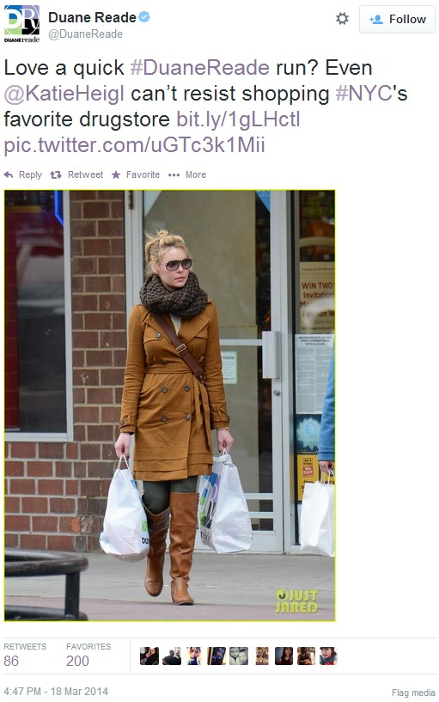

3. Non-Celebrities Right of Publicity and Social Media. In 2011, Facebook introduced its “Sponsored Stories” feature, which established as a default setting the insertion of advertisements into a user’s newsfeed based on recent conduct by the user, such as Like-ing an advertiser’s Facebook page or sharing location-based check-in information related to an advertiser. Distinguished only by the heading “Sponsored Story,” these advertisements looked very similar to a user’s status updates (see below). Facebook user’s brought a class action asserting violation of users’ right of publicity under California Civil Code § 3344(a). After the Northern District of California rejected Facebook’s motion to dismiss under § 3344(d)’s newsworthiness exception, Fraley v. Facebook, Inc., 830 F. Supp. 2d 785 (N.D. Cal. 2011), Facebook ended its Sponsored Stories program and paid $20 million to settle the dispute. See Mike Wheatley, Facebook Kills “Sponsored Stories” but Your Face Will Still Be Used in Ads, SiliconANGLE.com, Jan. 13, 2014, http://siliconangle.com/blog/2014/01/13/facebook-kills-sponsored-stories-but-your-face-will-still-be-used-in-its-ads/. In a press release, Facebook announced a different approach: “Last year … [w]e also announced that marketers will no longer be able to purchase sponsored stories separately; instead, social context—stories about social actions your friends have taken, such as liking a page or checking in to a restaurant—is now eligible to appear next to all ads shown to friends on Facebook.” An Update to Facebook Ads, Facebook.com Jan. 9, 2014, https://www.facebook.com/notes/facebook-and-privacy/an-update-to-facebook-ads/643198592396693.

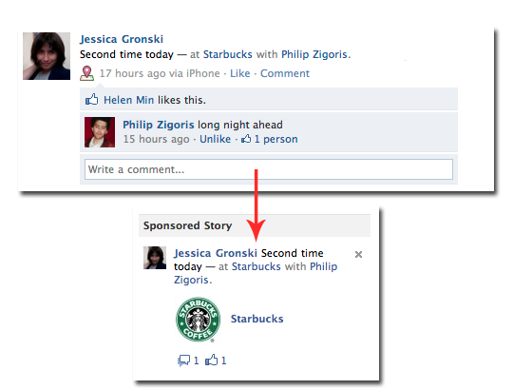

See J. Thomas McCarthy, The Rights of Publicity and Privacy § 6:2 (April 2017). See also Jennifer Rothman’s http://www.rightofpublicityroadmap.com/.
Under Professor Prosser's scheme, the right of publicity is the last of the four categories of the right to privacy. Prosser, 48 Cal.L.Rev. at 389.
The statute was amended after White filed her complaint. The amendments would not have altered the analysis in this case however.
In warning of a first amendment chill to expressive conduct, the dissent reads this decision too broadly. See Dissent at 1407. This case concerns only the market which exists in our society for the exploitation of celebrity to sell products, and an attempt to take a free ride on a celebrity's celebrity value. Commercial advertising which relies on celebrity fame is different from other forms of expressive activity in two crucial ways. First, for celebrity exploitation advertising to be effective, the advertisement must evoke the celebrity's identity. The more effective the evocation, the better the advertisement. If, as Samsung claims, its ad was based on a “generic” game-show hostess and not on Vanna White, the ad would not have violated anyone's right of publicity, but it would also not have been as humorous or as effective. Second, even if some forms of expressive activity, such as parody, do rely on identity evocation, the first amendment hurdle will bar most right of publicity actions against those activities. Cf. Falwell, 485 U.S. at 46. In the case of commercial advertising, however, the first amendment hurdle is not so high. Central Hudson Gas & Electric Corp. v. Public Service Comm'n of New York, 447 U.S. 557, 566 (1980). Realizing this, Samsung attempts to elevate its ad above the status of garden-variety commercial speech by pointing to the ad's parody of Vanna White. Samsung's argument is unavailing. See Board of Trustees, State Univ. of N.Y. v. Fox, 492 U.S. 469, 474–75 (1988); Bolger v. Youngs Drug Products Corp., 463 U.S. 60, 67–68, (1983). Unless the first amendment bars all right of publicity actions—and it does not, see Zachini v. Scripps–Howard Broadcasting Co., 433 U.S. 562 (1977)—then it does not bar this case.
See Eben Shapiro, Rising Caution on Using Celebrity Images, N.Y. Times, Nov. 4, 1992, at D20 (Iraqi diplomat objects on right of publicity grounds to ad containing Hussein's picture and caption “History has shown what happens when one source controls all the information”).
Eastwood v. Superior Court, 149 Cal.App.3d 409, 198 Cal.Rptr. 342 (1983).
Guglielmi v. Spelling-Goldberg Prods., 25 Cal.3d 860, 160 Cal.Rptr. 352, 603 P.2d 454 (1979) (Rudolph Valentino); see also Maheu v. CBS, Inc., 201 Cal.App.3d 662, 668, 247 Cal.Rptr. 304 (1988) (aide to Howard Hughes). Cf. Frank Gannon, Vanna Karenina, in Vanna Karenina and Other Reflections (1988) (A humorous short story with a tragic ending. “She thought of the first day she had met VR__SKY. How foolish she had been. How could she love a man who wouldn't even tell her all the letters in his name?”).
Girl Scouts v. Personality Posters Mfg., 304 F.Supp. 1228 (S.D.N.Y.1969) (poster of a pregnant girl in a Girl Scout uniform with the caption “Be Prepared”).
Lucasfilm Ltd. v. High Frontier, 622 F.Supp. 931 (D.D.C.1985).
Pepsico Inc. claimed the lyrics and packaging of grunge rocker Tad Doyle's “Jack Pepsi” song were “offensive to [it] and [ ...] likely to offend [its] customers,” in part because they “associate [Pepsico] and its Pepsi marks with intoxication and drunk driving.” Deborah Russell, Doyle Leaves Pepsi Thirsty for Compensation, Billboard, June 15, 1991, at 43. Conversely, the Hell's Angels recently sued Marvel Comics to keep it from publishing a comic book called “Hell's Angel,” starring a character of the same name. Marvel settled by paying $35,000 to charity and promising never to use the name “Hell's Angel” again in connection with any of its publications. Marvel, Hell's Angels Settle Trademark Suit, L.A. Daily J., Feb. 2, 1993, § II, at 1. Trademarks are often reflected in the mirror of our popular culture. See Truman Capote, Breakfast at Tiffany's (1958); Kurt Vonnegut, Jr., Breakfast of Champions (1973); Tom Wolfe, The Electric Kool-Aid Acid Test (1968) (which, incidentally, includes a chapter on the Hell's Angels); Larry Niven, Man of Steel, Woman of Kleenex, in All the Myriad Ways (1971); Looking for Mr. Goodbar (1977); The Coca-Cola Kid (1985) (using Coca-Cola as a metaphor for American commercialism); The Kentucky Fried Movie (1977); Harley Davidson and the Marlboro Man (1991); The Wonder Years (ABC 1988-present) (“Wonder Years” was a slogan of Wonder Bread); Tim Rice & Andrew Lloyd Webber, Joseph and the Amazing Technicolor Dream Coat (musical). Hear Janis Joplin, Mercedes Benz, on Pearl (CBS 1971); Paul Simon, Kodachrome, on There Goes Rhymin' Simon (Warner 1973); Leonard Cohen, Chelsea Hotel, on The Best of Leonard Cohen (CBS 1975); Bruce Springsteen, Cadillac Ranch, on The River (CBS 1980); Prince, Little Red Corvette, on 1999 (Warner 1982); dada, Dizz Knee Land, on Puzzle (IRS 1992) (“I just robbed a grocery store—I'm going to Disneyland / I just flipped off President George—I'm going to Disneyland”); Monty Python, Spam, on The Final Rip Off (Virgin 1988); Roy Clark, Thank God and Greyhound [You're Gone], on Roy Clark's Greatest Hits Volume I (MCA 1979); Mel Tillis, Coca-Cola Cowboy, on The Very Best of (MCA 1981) (“You're just a Coca-Cola cowboy / You've got an Eastwood smile and Robert Redford hair ...”). Dance to Talking Heads, Popular Favorites 1976-92: Sand in the Vaseline (Sire 1992); Talking Heads, Popsicle, on id. Admire Andy Warhol, Campbell's Soup Can. Cf. REO Speedwagon, 38 Special, and Jello Biafra of the Dead Kennedys. The creators of some of these works might have gotten permission from the trademark owners, though it's unlikely Kool-Aid relished being connected with LSD, Hershey with homicidal maniacs, Disney with armed robbers, or Coca-Cola with cultural imperialism. Certainly no free society can demand that artists get such permission.
Lombardo v. Doyle, Dane & Bernbach, Inc., 58 A.D.2d 620, 396 N.Y.S.2d 661 (1977).
Geller v. Fallon McElligott, No. 90-Civ-2839 (S.D.N.Y. July 22, 1991) (involving a Timex ad).
Prudhomme v. Procter & Gamble Co., 800 F.Supp. 390 (E.D.La.1992).
E.g., Acuff-Rose Music, Inc. v. Campbell, 972 F.2d 1429 (6th Cir.1992); Cliffs Notes v. Bantam Doubleday Dell Publishing Group, Inc., 886 F.2d 490 (2d Cir.1989); Fisher v. Dees, 794 F.2d 432 (9th Cir.1986); MCA, Inc. v. Wilson, 677 F.2d 180 (2d Cir.1981); Elsmere Music, Inc. v. NBC, 623 F.2d 252 (2d Cir.1980); Walt Disney Prods. v. The Air Pirates, 581 F.2d 751 (9th Cir.1978); Berlin v. E.C. Publications, Inc., 329 F.2d 541 (2d Cir.1964); Lowenfels v. Nathan, 2 F.Supp. 73 (S.D.N.Y.1932).
See Wendy J. Gordon, A Property Right in Self Expression: Equality and Individualism in the Natural Law of Intellectual Property, 102 Yale L.J. 1533, 1556-57 (1993).
I had never heard of Morton Downey, Jr., but I'm told he's sort of like Rush Limbaugh, but not as shy.
Cf., e.g., Guinn v. United States, 238 U.S. 347, 364-65, 35 S.Ct. 926, 931, 59 L.Ed. 1340 (1915) (striking down grandfather clause that was a clear attempt to evade the Fifteenth Amendment).
It would be called “Burden of Going Forward with the Evidence,” and the hero would ultimately be saved by his lawyer's adept use of Fed.R.Evid. 301.
In the words of Sir Isaac Newton, “[i]f I have seen further it is by standing on [the shoulders] of Giants.” Letter to Robert Hooke, Feb. 5, 1675/1676. Newton himself may have borrowed this phrase from Bernard of Chartres, who said something similar in the early twelfth century. Bernard in turn may have snatched it from Priscian, a sixth century grammarian. See Lotus Dev. Corp. v. Paperback Software Int'l, 740 F.Supp. 37, 77 n. 3 (D.Mass.1990).
In fact, in the one California case raising the issue, the three state Supreme Court Justices who discussed this theory expressed serious doubts about it. Guglielmi v. Spelling-Goldberg Prods., 25 Cal.3d 860, 864 n. 5, 160 Cal.Rptr. 352, 355 n. 5, 603 P.2d 454, 457 n. 5 (1979) (Bird, C.J., concurring) (expressing skepticism about finding a property right to a celebrity's “personality” because it is “difficult to discern any easily applied definition for this amorphous term”). Neither have we previously interpreted California law to cover pure “identity.” Midler v. Ford Motor Co., 849 F.2d 460 (9th Cir.1988), and Waits v. Frito-Lay, Inc., 978 F.2d 1093 (9th Cir.1992), dealt with appropriation of a celebrity's voice. See id. at 1100-01 (imitation of singing style, rather than voice, doesn't violate the right of publicity). Motschenbacher v. R.J. Reynolds Tobacco Co., 498 F.2d 821 (9th Cir.1974), stressed that, though the plaintiff's likeness wasn't directly recognizable by itself, the surrounding circumstances would have made viewers think the likeness was the plaintiff's. Id. at 827; see also Moore v. Regents of the Univ. of Cal., 51 Cal.3d 120, 138, 271 Cal.Rptr. 146, 157, 793 P.2d 479, 490 (1990) (construing Motschenbacher as “hold [ing] that every person has a proprietary interest in his own likeness”).
Some viewers might have inferred White was endorsing the product, but that's a different story. The right of publicity isn't aimed at or limited to false endorsements, Eastwood v. Superior Court, 149 Cal.App.3d 409, 419-20, 198 Cal.Rptr. 342, 348 (1983); that's what the Lanham Act is for. Note also that the majority's rule applies even to advertisements that unintentionally remind people of someone. California law is crystal clear that the common-law right of publicity may be violated even by unintentional appropriations. Id. at 417 n. 6, 198 Cal.Rptr. at 346 n. 6; Fairfield v. American Photocopy Equipment Co., 138 Cal.App.2d 82, 87, 291 P.2d 194 (1955).
Once the right of publicity is extended beyond specific physical characteristics, this will become a recurring problem: Outside name, likeness and voice, the things that most reliably remind the public of celebrities are the actions or roles they're famous for. A commercial with an astronaut setting foot on the moon would evoke the image of Neil Armstrong. Any masked man on horseback would remind people (over a certain age) of Clayton Moore. And any number of songs—“My Way,” “Yellow Submarine,” “Like a Virgin,” “Beat It,” “Michael, Row the Boat Ashore,” to name only a few—instantly evoke an image of the person or group who made them famous, regardless of who is singing. See also Carlos V. Lozano, West Loses Lawsuit over Batman TV Commercial, L.A. Times, Jan. 18, 1990, at B3 (Adam West sues over Batman-like character in commercial); Nurmi v. Peterson, 10 U.S.P.Q.2d 1775, 1989 WL 407484 (C.D.Cal.1989) (1950s TV movie hostess “Vampira” sues 1980s TV hostess “Elvira”); text accompanying notes 7-8 (lawsuits brought by Guy Lombardo, claiming big bands playing at New Year's Eve parties remind people of him, and by Uri Geller, claiming psychics who can bend metal remind people of him). Cf. Motschenbacher, where the claim was that viewers would think plaintiff was actually in the commercial, and not merely that the commercial reminded people of him.
See generally Gordon, supra note 11; see also Michael Madow, Private Ownership of Public Image: Popular Culture and Publicity Rights, 81 Cal.L.Rev. 125, 201-03 (1993) (an excellent discussion).
See 35 U.S.C. § 154 (duration of patent); 17 U.S.C. §§ 302-305 (duration of copyright); 17 U.S.C. § 102(b) (idea-expression dichotomy); 17 U.S.C. § 107 (fair use); Feist Pubs., Inc. v. Rural Tel. Serv. Co., 499 U.S. 340, ----, 111 S.Ct. 1282, 1288, 113 L.Ed.2d 358 (1991) (no copyrighting facts); 17 U.S.C. §§ 115, 119(b) (compulsory licenses); Bonito Boats, Inc. v. Thunder Craft Boats, Inc., 489 U.S. 141, 109 S.Ct. 971, 103 L.Ed.2d 118 (1989) (federal preemption); New Kids on the Block v. News America Publishing, Inc., 971 F.2d 302, 306-308 (9th Cir.1992) (nominative use); 17 U.S.C. § 114(b) (soundalikes); accord G.S. Rasmussen & Assocs. v. Kalitta Flying Serv., Inc., 958 F.2d 896, 900 n. 7 (9th Cir.1992); Daniel A. Saunders, Comment, Copyright Law's Broken Rear Window, 80 Cal.L.Rev. 179, 204-05 (1992). But see Midler v. Ford Motor Co., 849 F.2d 460 (9th Cir.1988).
If Christian Slater, star of “Heathers,” “Pump up the Volume,” “Kuffs,” and “Untamed Heart”—and alleged Jack Nicholson clone—appears in a commercial, can Nicholson sue? Of 54 stories on LEXIS that talk about Christian Slater, 26 talk about Slater's alleged similarities to Nicholson. Apparently it's his nasal wisecracks and killer smiles, St. Petersburg Times, Jan. 10, 1992, at 13, his eyebrows, Ottawa Citizen, Jan. 10, 1992, at E2, his sneers, Boston Globe, July 26, 1991, at 37, his menacing presence, USA Today, June 26, 1991, at 1D, and his sing-song voice, Gannett News Service, Aug. 27, 1990 (or, some say, his insinuating drawl, L.A. Times, Aug. 22, 1990, at F5). That's a whole lot more than White and the robot had in common.
Cf. New Kids on the Block v. News America Publishing, Inc., 971 F.2d 302, 307 n. 6 (9th Cir.1992) (“Where the infringement is small in relation to the new work created, the fair user is profiting largely from his own creative efforts rather than free-riding on another's work.”).
The majority opinion has already earned some well-deserved criticisms on this score. Stephen R. Barnett, In Hollywood's Wheel of Fortune, Free Speech Loses a Turn, Wall St. J., Sept. 28, 1992, at A14; Stephen R. Barnett, Wheel of Misfortune for Advertisers: Ninth Circuit Misreads the Law to Protect Vanna White's Image, L.A. Daily J., Oct. 5, 1992, at 6; Felix H. Kent, California Court Expands Celebrities' Rights, N.Y.L.J., Oct. 30, 1992, at 3 (“To speak of the ‘evisceration’ of such a questionable common law right in a case that has probably gone the farthest of any case in any court in the United States of America is more than difficult to comprehend”); Shapiro, supra note 1 (“A fat chef? A blond robot in an evening gown? How far will this go?” (citing Douglas J. Wood, an advertising lawyer)). See also Mark Alan Stamaty, Washingtoon, Wash. Post, Apr. 5, 1993, at A21.
Just compare the majority's holding to the intellectual property laws upheld by the Supreme Court. The Copyright Act is constitutional precisely because of the fair use doctrine and the idea-expression dichotomy, Harper & Row v. Nation Enterprises, 471 U.S. 539, 560, 105 S.Ct. 2218, 2230, 85 L.Ed.2d 588 (1985), two features conspicuously absent from the majority's doctrine. The right of publicity at issue in Zacchini v. Scripps-Howard Broadcasting Co., 433 U.S. 562, 576, 97 S.Ct. 2849, 2857-58, 53 L.Ed.2d 965 (1977), was only the right to “broadcast of petitioner's entire performance,” not “the unauthorized use of another's name for purposes of trade.” Id. Even the statute upheld in San Francisco Arts & Athletics, Inc. v. United States Olympic Comm., 483 U.S. 522, 530, 107 S.Ct. 2971, 2977, 97 L.Ed.2d 427 (1987), which gave the USOC sweeping rights to the word “Olympic,” didn't purport to protect all expression that reminded people of the Olympics.
The majority's failure to recognize a parody exception to the right of publicity would apply equally to parodies of politicians as of actresses. Consider the case of Wok Fast, a Los Angeles Chinese food delivery service, which put up a billboard with a picture of then-L.A. Police Chief Daryl Gates and the text “When you can't leave the office. Or won't.” (This was an allusion to Chief Gates's refusal to retire despite pressure from Mayor Tom Bradley.) Gates forced the restaurant to take the billboard down by threatening a right of publicity lawsuit. Leslie Berger, He Did Leave the Office-And Now Sign Will Go, Too, L.A. Times, July 31, 1992, at B2. See also Samsung Has Seen the Future: Brace Youself, Adweek, Oct. 3, 1988, at 26 (ER 72) (Samsung planned another ad that would show a dollar bill with Richard Nixon's face on it and the caption ‘Dollar bill, 2025 A.D..,‘ but Nixon refused permission to use his likeness); Madow supra note 19, at 142-46 (discussing other politically and culturally charged parodies).
See, e.g., Bruce Horovitz, Nike Does It Again; Firm Targets Blacks with a Spin on “Family Values”, L.A. Times, Aug. 25, 1992, at D1 (“The ad reinforces a stereotype about black fathers” (quoting Lawrence A. Johnson of Howard University)); Gaylord Fields, Advertising Awards-Show Mania: CEBA Awards Honors Black-Oriented Advertising, Back Stage, Nov. 17, 1989, at 1 (quoting the Rev. Jesse Jackson as emphasizing the importance of positive black images in advertising); Debra Kaufman, Quality of Hispanic Production Rising to Meet Clients' Demands, Back Stage, July 14, 1989, at 1 (Hispanic advertising professional stresses importance of positive Hispanic images in advertising); Marilyn Elias, Medical Ads Often Are Sexist, USA Today, May 18, 1989, at 1D (“There's lots of evidence that this kind of ad reinforces stereotypes” (quoting Julie Edell of Duke University)).
See Wendy's Kind of Commercial; “Where's the Beef” Becomes National Craze, Broadcasting, Mar. 26, 1984, at 57.
See Gregory Gordon, Candidates Look for Feedback Today, UPI, Sept. 26, 1988.
Its only citation to Central Hudson is a seeming afterthought, buried in a footnote, and standing only for the proposition that commercial speech is less protected under the First Amendment. See 971 F.2d at 1401 n. 3.
See also Board of Trustees v. Fox, 492 U.S. 469, 476-81, 109 S.Ct. 3028, 3032-35, 106 L.Ed.2d 388 (1989) (reaffirming “narrowly tailored” requirement, but making clear it's not a “least restrictive means” test). The government has a freer hand in regulating false or misleading commercial speech, but this isn't such a regulation. Some “appropriations” of a person's “identity” might misleadingly suggest an endorsement, but the mere possibility that speech might mislead isn't enough to strip it of First Amendment protection. See Zauderer v. Office of Disciplinary Counsel, 471 U.S. 626, 644 (1985).
Neither does it discuss whether the speech restriction is unconstitutionally vague. Posadas de P.R. Assocs. v. Tourism Co., 478 U.S. 328, 347, 106 S.Ct. 2968, 2980, 92 L.Ed.2d 266 (1986).
All such images are taken from Wikipedia or Georgetown Law Intellectual Property Teaching Resources.
. In Brown v. Electronic Arts, Inc., No. 09–56675, 724 F.3d 1235, 1241–42, 2013 WL 3927736, at *3 (9th Cir. July 31, 2013), we noted that “there may be some work referred to as a ‘video game’ (or referred to as a ‘book,’ ‘play,’ or ‘movie’ for that matter) that does not contain enough of the elements contemplated by the Supreme Court [in Brown v. Entertainment Merchants Association ] to warrant First Amendment protection as an expressive work,” but asserted that “[e]ven if there is a line to be drawn between expressive video games and non-expressive video games, and even if courts should at some point be drawing that line, we have no need to draw that line here.” The same holds true in this case.
There are actually nine named plaintiffs, all former National Collegiate Athletic Association (“NCAA”) football or basketball players: Keller, Edward O'Bannon, Jr. (UCLA), Byron Bishop (University of North Carolina), Michael Anderson (University of Memphis), Danny Wimprine (University of Memphis), Ishmael Thrower (Arizona State University), Craig Newsome (Arizona State University), Damien Rhodes (Syracuse University), and Samuel Jacobson (University of Minnesota). EA's NCAA basketball games are also implicated in this appeal. Because the issues are the same for each plaintiff, all of the claims are addressed through our discussion of Keller and NCAA Football.
We review de novo the district court's denial of a motion to strike under California's anti-SLAPP statute. Mindys Cosmetics, Inc. v. Dakar, 611 F.3d 590, 595 (9th Cir.2010).
The elements of a right-of-publicity claim under California common law are: “(1) the defendant's use of the plaintiff's identity; (2) the appropriation of plaintiff's name or likeness to defendant's advantage, commercially or otherwise; (3) lack of consent; and (4) resulting injury.” Stewart v. Rolling Stone LLC, 181 Cal.App.4th 664, 105 Cal.Rptr.3d 98, 111 (internal quotation marks omitted). The same claim under California Civil Code § 3344 requires a plaintiff to prove “all the elements of the common law cause of action” plus “a knowing use by the defendant as well as a direct connection between the alleged use and the commercial purpose.” Id.
Just as we did in Hilton v. Hallmark Cards, we reserve the question of whether the First Amendment furnishes a defense other than those the parties raise. 599 F.3d 894, 909 n. 11 (9th Cir.2010).
We also briefly addressed the transformative use test in a footnote in Hoffman v. Capital Cities/ABC, Inc., 255 F.3d 1180 (9th Cir.2001). We indicated that if we had considered the test, we would have concluded that an image of Dustin Hoffman from “Tootsie” that had been altered to make it appear like he was wearing fashions from a decade later “contained ‘significant transformative elements.’ ” Id. at 1184 n. 2; 1182–83. “Hoffman's body was eliminated and a new, differently clothed body was substituted in its place. In fact, the entire theory of Hoffman's case rests on his allegation that the photograph is not a ‘true’ or ‘literal’ depiction of him, but a false portrayal.” Id. at 1184 n. 2.
Judge Thomas argues that the “sheer number of virtual actors,” the absence of “any evidence as to the personal marketing power of Sam Keller,” and the relative anonymity of each individual player in NCAA Football as compared to the public figures in other California right-of-publicity cases all mitigate in favor of finding that the EA's First Amendment rights outweigh Keller's right of publicity. See Dissent at 1286–88. These facts are not irrelevant to the analysis—they all can be considered in the framework of the five considerations from Comedy III laid out above—but the fact is that EA elected to use avatars that mimic real college football players for a reason. If EA did not think there was value in having an avatar designed to mimic each individual player, it would not go to the lengths it does to achieve realism in this regard. Having chosen to use the players' likenesses, EA cannot now hide behind the numerosity of its potential offenses or the alleged unimportance of any one individual player.
EA further argues that No Doubt is distinguishable because the video game company in that case entered into a license agreement which it allegedly breached. However, the California Court of Appeal did not rely on breach of contract in its analysis of whether the game was transformative. 122 Cal.Rptr.3d at 412 n. 7. Keller asserts here that EA contracted away its First Amendment rights in a licensing agreement with the NCAA that purportedly prohibited the use of athlete likenesses. However, in light of our conclusion that EA is not entitled to a First Amendment defense as a matter of law, we need not reach this issue and leave it for the district court to address in the first instance on remand should the finder of fact determine in post-SLAPP proceedings that EA's use is transformative.
In dissent, Judge Thomas suggests that this case is distinguishable from other right-to-publicity cases because “an individual college athlete's right of publicity is extraordinarily circumscribed and, in practical reality, nonexistent” because “NCAA rules prohibit athletes from benefitting economically from any success on the field.” Dissent at 1289. Judge Thomas commendably addresses the fairness of this structure, see Dissent at 1289 n. 5, but setting fairness aside, the fact is that college athletes are not indefinitely bound by NCAA rules. Once an athlete graduates from college, for instance, the athlete can capitalize on his success on the field during college in any number of ways. EA's use of a college athlete's likeness interferes with the athlete's right to capitalize on his athletic success once he is beyond the dominion of NCAA rule.
Judge Thomas asserts that “[t]he logical consequence of the majority view is that all realistic depictions of actual persons, no matter how incidental, are protected by a state law right of publicity regardless of the creative context,” “jeopardiz[ing] the creative use of historic figures in motion pictures, books, and sound recordings.” Dissent at 1290. We reject the notion that our holding has such broad consequences. As discussed above, one of the factors identified in Comedy III “requires an examination of whether a likely purchaser's primary motivation is to buy a reproduction of the celebrity, or to buy the expressive work of that artist.” McCarthy, supra, § 8:72; see Comedy III, 106 Cal.Rptr.2d 126, 21 P.3d at 809. Certainly this leaves room for distinguishing between this case—where we have emphasized EA's primary emphasis on reproducing reality—and cases involving other kinds of expressive works.
Keller argues that EA never asked the district court to apply Rogers and has therefore waived the issue on appeal. Although it could have been more explicit, EA's anti-SLAPP motion did cite Rogers and argue that Keller had not alleged that his likeness was “wholly unrelated” to the content of the video game or a “disguised commercial advertisement,” the two prongs of the Rogers test.
We similarly reject Judge Thomas's argument that Keller's right-of-publicity claim should give way to the First Amendment in light of the fact that “the essence of NCAA Football is founded on publicly available data.” Dissent at 1288. Judge Thomas compares NCAA Football to the fantasy baseball products that the Eighth Circuit deemed protected by the First Amendment in the face of a right-of-publicity claim in C.B.C. Distribution and Marketing, 505 F.3d at 823–24. Dissent at 1288. But there is a big difference between a video game like NCAA Football and fantasy baseball products like those at issue in C.B.C. Those products merely “incorporate[d] the names along with performance and biographical data of actual major league baseball players.” Id. at 820. NCAA Football, on the other hand, uses virtual likenesses of actual college football players. It is seemingly true that each likeness is generated largely from publicly available data—though, as Judge Thomas acknowledges, EA solicits certain information directly from schools—but finding this fact dispositive would neuter the right of publicity in our digital world. Computer programmers with the appropriate expertise can create a realistic likeness of any celebrity using only publicly available data. If EA creates a virtual likeness of Tom Brady using only publicly available data—public images and videos of Brady—does EA have free reign to use that likeness in commercials without violating Brady's right of publicity? We think not, and thus must reject Judge Thomas's point about the public availability of much of the data used given that EA produced and used actual likenesses of the athletes involved.
I agree with the majority that the test articulated in Rogers v. Grimaldi, 875 F.2d 994 (2d Cir.1989), should not be employed in this context. The Rogers test is appropriately applied in Lanham Act cases, where the primary concern is with the danger of consumer confusion when a work is depicted as something it is not. 15 U.S.C. § 1125(a)(1). However, the right of publicity is an economic right to use the value of one own's celebrity. Zacchini v. Scripps–Howard Broad. Co., 433 U.S. 562, 576–77, 97 S.Ct. 2849, 53 L.Ed.2d 965 (1977). Therefore, a more nuanced balancing is required. In our context, I believe the transformative use test—if correctly applied to the work as a whole—provides the proper analytical framework.
I agree fully with Judge Ambro's excellent dissent in Hart, which describes the analytic flaws of applying a transformative use test outside the context of the work as a whole.
Of course, to the extent that the Court of Appeal's opinion in No Doubt may be read to be in tension with the transformative use test as articulated by the California Supreme Court in Comedy III and Winter, it must yield.
Contrary to the majority's suggestion, I do not claim that any use of a likeness founded on publicly available information is transformative. Majority op. 1283–84 n. 12. The majority's analogy to a commercial featuring Tom Brady is inapposite for at least two reasons: (1) a commercial is not interactive in the same way that NCAA Football is, and (2) Brady's marketing power is well established, while that of the plaintiffs is not.
The issue of whether this structure is fair to the student athlete is beyond the scope of this appeal, but forms a significant backdrop to the discussion. The NCAA received revenues of $871.6 million in fiscal year 2011–12, with 81% of the money coming from television and marketing fees. However, few college athletes will ever receive any professional compensation. The NCAA reports that in 2011, there were 67,887 college football players. Of those, 15,086 were senior players, and only 255 athletes were drafted for a professional team. Thus, only 1.7% of seniors received any subsequent professional economic compensation for their athletic endeavors. NCAA, Estimated Probability of Competing in Athletics Beyond the High School Interscholastic Level (2011), available at http:// www. ncaa. org/ wps/ wcm/ connect/ public/ ncaa/ pdfs/ 2011/ 2011+ probability+ of+ going+ pro. And participation in college football can come at a terrible cost. The NCAA reports that, during a recent five-year period, college football players suffered 41,000 injuries, including 23 non-fatal catastrophic injuries and 11 fatalities from indirect catastrophic injuries. NCAA, Football Injuries: Data From the 2004/05 to 2008/09 Seasons, available at http:// www. ncaa. org/ wps/ wcm/ connect/ public/ ncaa/ health+ and+ safety/ sports+ injuries/ resources/ football+ injuries.
While acknowledging that these considerations are relevant to the Comedy III analysis, the majority says EA's use of realistic likenesses demonstrates that it sees “value in having an avatar designed to mimic each individual player.” Majority op. at 1276 n. 7. But the same is true of any right of publicity case. The defendants in Winter saw value in using comic book characters that resembled the Winter brothers. Andy Warhol—whose portraits were discussed in Comedy III—saw value in using images of celebrities such as Marilyn Monroe. In those cases, the products' marketability derives primarily from the creative elements, not from a pure commercial exploitation of a celebrity image. The same is true of NCAA Football.
See, e.g., ETW Corp. v. Jireh Publ'g, Inc., 332 F.3d 915 (6th Cir.2003) (affording First Amendment protection to an artist's use of photographs of Tiger Woods); J. Thomas McCarthy, The Rights of Publicity and Privacy § 8.65 (2013 ed.) (collecting cases); Hart, 717 F. 3d at 173 (Ambro, J., dissenting) (describing cases). Football.
From http://siliconangle.com/blog/2014/01/13/facebook-kills-sponsored-stories-but-your-face-will-still-be-used-in-its-ads/.

