Multi Time Machine v. Amazon.com
804 F.3d 930 (9th Cir. Oct. 21, 2015), superseding 792 F.3d 1070 (9th Cir. July 6, 2015)

SILVERMAN, Circuit Judge:
[1] In the present appeal, we must decide whether the following scenario constitutes trademark infringement: A customer goes online to Amazon.com looking for a certain military-style wristwatch—specifically the “MTM Special Ops”—marketed and manufactured by Plaintiff Multi Time Machine, Inc. The customer types “mtm special ops” in the search box and presses “enter.” Because Amazon does not sell the MTM Special Ops watch, what the search produces is a list, with photographs, of several other brands of military style watches that Amazon does carry, specifically identified by their brand names—Luminox, Chase–Durer, TAWATEC, and Modus.
[2] MTM brought suit alleging that Amazon’s response to a search for the MTM Special Ops watch on its website is trademark infringement in violation of the Lanham Act. MTM contends that Amazon’s search results page creates a likelihood of confusion, even though there is no evidence of any actual confusion and even though the other brands are clearly identified by name. The district court granted summary judgment in favor of Amazon, and MTM now appeals.
[3] We affirm. “The core element of trademark infringement” is whether the defendant’s conduct “is likely to confuse customers about the source of the products.” E. & J. Gallo Winery v. Gallo Cattle Co., 967 F.2d 1280, 1290 (9th Cir.1992). Because Amazon’s search results page clearly labels the name and manufacturer of each product offered for sale and even includes photographs of the items, no reasonably prudent consumer accustomed to shopping online would likely be confused as to the source of the products. Thus, summary judgment of MTM’s trademark claims was proper.

I. Factual and Procedural Background
[4] MTM manufactures and markets watches under various brand names including MTM, MTM Special Ops, and MTM Military Ops. MTM holds the federally registered trademark “MTM Special Ops” for timepieces. MTM sells its watches directly to its customers and through various retailers. To cultivate and maintain an image as a high-end, exclusive brand, MTM does not sell its watches through Amazon.com. Further, MTM does not authorize its distributors, whose agreements require them to seek MTM’s permission to sell MTM’s products anywhere but their own retail sites, to sell MTM watches on Amazon.com. Therefore, MTM watches have never been available for sale on Amazon.com.
[5] Amazon is an online retailer that purports to offer “Earth’s Biggest Selection of products.” Amazon has designed its website to enable millions of unique products to be sold by both Amazon and third party sellers across dozens of product categories.
[6] Consumers who wish to shop for products on Amazon’s website can utilize Amazon’s search function…. In order to provide search results in which the consumer is most likely to be interested, Amazon’s search function does not simply match the words in the user’s query to words in a document, such as a product description in Amazon.com’s catalog. Rather, Amazon’s search function—like general purpose web search engines such as Google or Bing—employs a variety of techniques, including some that rely on user behavior, to produce relevant results. By going beyond exactly matching a user’s query to text describing a product, Amazon’s search function can provide consumers with relevant results that would otherwise be overlooked.
[7] Consumers who go onto Amazon.com and search for the term “mtm special ops” are directed to a search results page. On the search results page, the search query used—here, “mtm special ops”—is displayed twice: in the search query box and directly below the search query box in what is termed a “breadcrumb.” The breadcrumb displays the original query, “mtm special ops,” in quotation marks to provide a trail for the consumer to follow back to the original search. Directly below the breadcrumb, is a “Related Searches” field, which provides the consumer with alternative search queries in case the consumer is dissatisfied with the results of the original search. Here, the Related Search that is suggested to the consumer is: “mtm special ops watch.” Directly below the “Related Searches” field is a gray bar containing the text “Showing 10 Results.” Then, directly below the gray bar is Amazon’s product listings. The gray bar separates the product listings from the breadcrumb and the “Related Searches” field. The particular search results page at issue is displayed below:
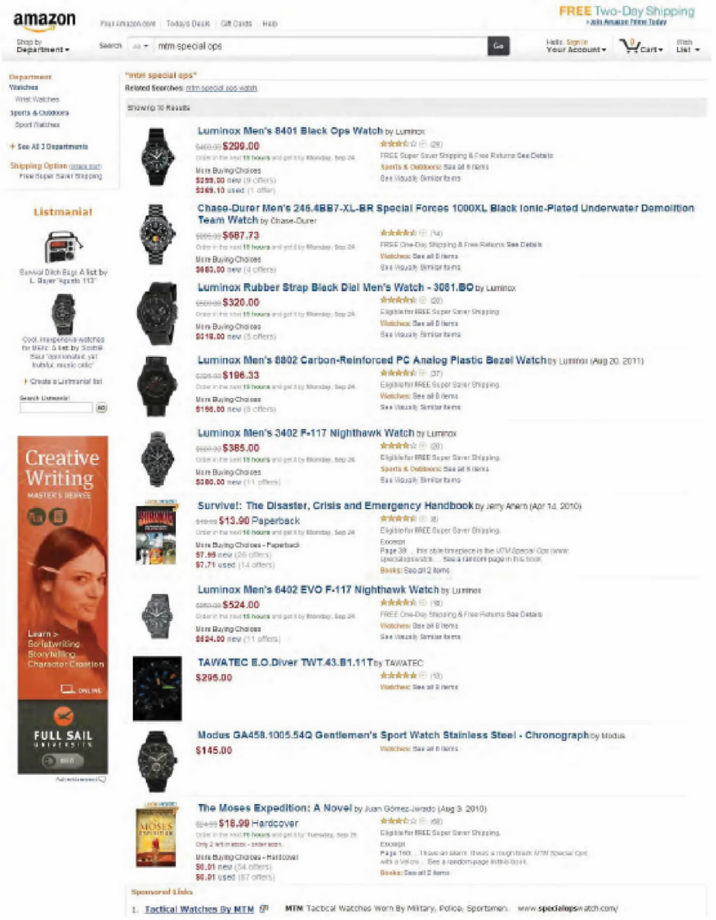

MTM watches are not listed on the page for the simple reason that neither Amazon nor MTM sells MTM watches on Amazon.
[8] MTM filed a complaint against Amazon, alleging that Amazon’s search results page infringes MTM’s trademarks in violation of the Lanham Act. Amazon filed a motion for summary judgment, arguing that (1) it is not using MTM’s mark in commerce and (2) there is no likelihood of consumer confusion. In ruling on Amazon’s motion for summary judgment, the district court declined to resolve the issue of whether Amazon is using MTM’s mark in commerce, and, instead, addressed the issue of likelihood of confusion. In evaluating likelihood of confusion, the district court utilized the eight-factor test set forth in AMF Inc. v. Sleekcraft Boats, 599 F.2d 341 (9th Cir.1979). Relying on our recent decision in Network Automation, Inc. v. Advanced Systems Concepts, 638 F.3d 1137 (9th Cir.2011), the district court focused in particular on the following factors: (1) the strength of MTM’s mark; (2) the evidence of actual confusion and the evidence of no confusion; (3) the type of goods and degree of care likely to be exercised by the purchaser; and (4) the appearance of the product listings and the surrounding context on the screen displaying the results page. Upon reviewing the factors, the district court concluded that the relevant Sleekcraft factors established “that there is no likelihood of confusion in Amazon’s use of MTM’s trademarks in its search engine or display of search results.” Therefore, the district court granted Amazon’s motion for summary judgment.
…

III. Discussion
…
[9] Here, the district court was correct in ruling that there is no likelihood of confusion. Amazon is responding to a customer’s inquiry about a brand it does not carry by doing no more than stating clearly (and showing pictures of) what brands it does carry. To whatever extent the Sleekcraft factors apply in a case such as this—a merchant responding to a request for a particular brand it does not sell by offering other brands clearly identified as such—the undisputed evidence shows that confusion on the part of the inquiring buyer is not at all likely. Not only are the other brands clearly labeled and accompanied by photographs, there is no evidence of actual confusion by anyone.
[10] To analyze likelihood of confusion, we utilize the eight-factor test set forth in Sleekcraft…. [T]he Sleekcraft factors are not exhaustive and other variables may come into play depending on the particular facts presented. Network Automation, 638 F.3d at 1145–46. This is particularly true in the Internet context. See Brookfield, 174 F.3d at 1054 (“We must be acutely aware of excessive rigidity when applying the law in the Internet context; emerging technologies require a flexible approach.”). Indeed, in evaluating claims of trademark infringement in cases involving Internet search engines, we have found particularly important an additional factor that is outside of the eight-factor Sleekcraft test: “the labeling and appearance of the advertisements and the surrounding context on the screen displaying the results page.” Network Automation, 638 F.3d at 1154.
[11] In the present case, the eight-factor Sleekcraft test is not particularly apt. This is not surprising as the Sleekcraft test was developed for a different problem—i.e., for analyzing whether two competing brands’ marks are sufficiently similar to cause consumer confusion. See Sleekcraft, 599 F.2d at 348. Although the present case involves brands that compete with MTM, such as Luminox, Chase–Durer, TAWATEC, and Modus, MTM does not contend that the marks for these competing brands are similar to its trademarks. Rather, MTM argues that the design of Amazon’s search results page creates a likelihood of initial interest confusion because when a customer searches for MTM Special Ops watches on Amazon.com, the search results page displays the search term used—here, “mtm special ops”—followed by a display of numerous watches manufactured by MTM’s competitors and offered for sale by Amazon, without explicitly informing the customer that Amazon does not carry MTM watches.
[12] Thus, the present case focuses on a different type of confusion than was at issue in Sleekcraft. Here, the confusion is not caused by the design of the competitor’s mark, but by the design of the web page that is displaying the competing mark and offering the competing products for sale. Sleekcraft aside, the ultimate test for determining likelihood of confusion is whether a “reasonably prudent consumer” in the marketplace is likely to be confused as to the origin of the goods. Dreamwerks, 142 F.3d at 1129. Our case can be resolved simply by a evaluation of the web page at issue and the relevant consumer. Cf. Brookfield, 174 F.3d at 1054 (“[I]t is often possible to reach a conclusion with respect to likelihood of confusion after considering only a subset of the factors.”). Indeed, we have previously noted that “[i]n the keyword advertising context [i.e., where a user performs a search on the internet, and based on the keywords contained in the search, the resulting web page displays certain advertisements containing products or services for sale,] the ‘likelihood of confusion will ultimately turn on what the consumer saw on the screen and reasonably believed, given the context.’ ” Network Automation, 638 F.3d at 1153. In other words, the case will turn on the answers to the following two questions: (1) Who is the relevant reasonable consumer?; and (2) What would he reasonably believe based on what he saw on the screen?
[13] Turning to the first question, we have explained that “[t]he nature of the goods and the type of consumer is highly relevant to determining the likelihood of confusion in the keyword advertising context.” Network Automation, 638 F.3d at 1152. “In evaluating this factor, we consider ‘the typical buyer exercising ordinary caution.’ ” Au–Tomotive Gold, Inc. v. Volkswagen of Am., Inc., 457 F.3d 1062, 1076 (9th Cir.2006) (quoting Sleekcraft, 599 F.2d at 353). “Confusion is less likely where buyers exercise care and precision in their purchases, such as for expensive or sophisticated items.” Id. Moreover, “the default degree of consumer care is becoming more heightened as the novelty of the Internet evaporates and online commerce becomes commonplace.” Network Automation, 638 F.3d at 1152.
[14] The goods in the present case are expensive. It is undisputed that the watches at issue sell for several hundred dollars. Therefore, the relevant consumer in the present case “is a reasonably prudent consumer accustomed to shopping online.” Toyota Motor Sales, U.S.A., Inc. v. Tabari, 610 F.3d 1171, 1176 (9th Cir.2010).
[15] Turning to the second question, as MTM itself asserts, the labeling and appearance of the products for sale on Amazon’s web page is the most important factor in this case. This is because we have previously noted that clear labeling can eliminate the likelihood of initial interest confusion in cases involving Internet search terms… MTM agrees that summary judgment of its trademark claims is appropriate if there is clear labeling that avoids likely confusion.
[16] Here, the products at issue are clearly labeled by Amazon to avoid any likelihood of initial interest confusion by a reasonably prudent consumer accustomed to online shopping. When a shopper goes to Amazon’s website and searches for a product using MTM’s trademark “mtm special ops,” the resulting page displays several products, all of which are clearly labeled with the product’s name and manufacturer in large, bright, bold letters and includes a photograph of the item. In fact, the manufacturer’s name is listed twice. For example, the first result is “Luminox Men’s 8401 Black Ops Watch by Luminox.” The second result is “Chase–Durer Men’s 246.4BB7–XL–BR Special Forces 1000XL Black Ionic–Plated Underwater Demolition Team Watch by Chase–Durer.” Because Amazon clearly labels each of the products for sale by brand name and model number accompanied by a photograph of the item, it is unreasonable to suppose that the reasonably prudent consumer accustomed to shopping online would be confused about the source of the goods.
[17] MTM argues that initial interest confusion might occur because Amazon lists the search term used—here the trademarked phrase “mtm special ops”—three times at the top of the search page. MTM argues that because Amazon lists the search term “mtm special ops” at the top of the page, a consumer might conclude that the products displayed are types of MTM watches. But, merely looking at Amazon’s search results page shows that such consumer confusion is highly unlikely. None of these watches is labeled with the word “MTM” or the phrase “Special Ops,” let alone the specific phrase “MTM Special Ops.” Further, some of the products listed are not even watches. The sixth result is a book entitled “Survive!: The Disaster, Crisis and Emergency Handbook by Jerry Ahem.” The tenth result is a book entitled “The Moses Expedition: A Novel by Juan Gómez–Jurado.” No reasonably prudent consumer, accustomed to shopping online or not, would assume that a book entitled “The Moses Expedition” is a type of MTM watch or is in any way affiliated with MTM watches. Likewise, no reasonably prudent consumer accustomed to shopping online would view Amazon’s search results page and conclude that the products offered are MTM watches. It is possible that someone, somewhere might be confused by the search results page. But, “[u]nreasonable, imprudent and inexperienced web-shoppers are not relevant.” Tabari, 610 F.3d at 1176; see also Network Automation, 638 F.3d at 1153 (“[W]e expect consumers searching for expensive products online to be even more sophisticated.”). To establish likelihood of confusion, MTM must show that confusion is likely, not just possible. See Murray, 86 F.3d at 861.
[18] MTM argues that in order to eliminate the likelihood of confusion, Amazon must change its search results page so that it explains to customers that it does not offer MTM watches for sale before suggesting alternative watches to the customer. We disagree. The search results page makes clear to anyone who can read English that Amazon carries only the brands that are clearly and explicitly listed on the web page. The search results page is unambiguous—not unlike when someone walks into a diner, asks for a Coke, and is told “No Coke. Pepsi.” See Multi Time Mach., Inc. v. Amazon.com, Inc., 792 F.3d 1070, 1080–81 (9th Cir.2015) (Silverman, J., dissenting).
…
[19] The likelihood of confusion is often a question of fact, but not always. In a case such as this, where a court can conclude that the consumer confusion alleged by the trademark holder is highly unlikely by simply reviewing the product listing/advertisement at issue, summary judgment is appropriate.
[20] Further, we are able to conclude that summary judgment is appropriate in the present case without delving into any factors other than: (1) the type of goods and the degree of care likely to be exercised by the purchaser; and (2) the labeling and appearance of the products for sale and the surrounding context on the screen displaying the results page… However, if we were to evaluate each of the remaining Sleekcraft factors, those factors would not change our conclusion, here, because those factors are either neutral or unimportant….

IV. Conclusion
[21] In light of Amazon’s clear labeling of the products it carries, by brand name and model, accompanied by a photograph of the item, no rational trier of fact could find that a reasonably prudent consumer accustomed to shopping online would likely be confused by the Amazon search results. Accordingly, we affirm the district court’s grant of summary judgment in favor of Amazon.

BEA, Circuit Judge, dissenting:
[1] Today the panel holds that when it comes to internet commerce, judges, not jurors, decide what labeling may confuse shoppers. In so doing, the court departs from our own trademark precedent and from our summary judgment jurisprudence. Because I believe that an Amazon shopper seeking an MTM watch might well initially think that the watches Amazon offers for sale when he searches “MTM Special Ops” are affiliated with MTM, I must dissent.
[2] If her brother mentioned MTM Special Ops watches, a frequent internet shopper might try to purchase one for him through her usual internet retail sites, perhaps Overstock.com, Buy.com, and Amazon.com. At Overstock’s site, if she typed “MTM special ops,” the site would respond “Sorry, your search: ‘mtm special ops’ returned no results.” Similarly, at Buy.com, she would be informed “0 results found. Sorry. Your search for mtm special ops did not return an exact match. Please try your search again.”
[3] Things are a little different over at “Earth’s most customer-centric company,” as Amazon styles itself. There, if she were to enter “MTM Special Ops” as her search request on the Amazon website, Amazon would respond with its page showing (1) MTM Special Ops in the search field (2) “MTM Specials Ops” again—in quotation marks—immediately below the search field and (3) yet again in the phrase “Related Searches: MTM special ops watch,” (emphasis in original) all before stating “Showing 10 Results.” What the website’s response will not state is the truth recognized by its competitors: that Amazon does not carry MTM products any more than do Overstock.com or Buy.com. Rather, below the search field, and below the second and third mentions of “MTM Special Ops” noted above, the site will display aesthetically similar, multi-function watches manufactured by MTM’s competitors. The shopper will see that Luminox and Chase–Durer watches are offered for sale, in response to her MTM query.
[4] MTM asserts the shopper might be confused into thinking a relationship exists between Luminox and MTM; she may think that MTM was acquired by Luminox, or that MTM manufactures component parts of Luminox watches, for instance. As a result of this initial confusion, MTM asserts, she might look into buying a Luminox watch, rather than junk the quest altogether and seek to buy an MTM watch elsewhere. MTM asserts that Amazon’s use of MTM’s trademarked name is likely to confuse buyers, who may ultimately buy a competitor’s goods.
[5] MTM may be mistaken. But whether MTM is mistaken is a question that requires a factual determination, one this court does not have authority to make.
[6] By usurping the jury function, the majority today makes new trademark law. When we allow a jury to determine whether there is a likelihood of confusion, as I would, we do not make trademark law, because we announce no new principle by which to adjudicate trademark disputes. Today’s brief majority opinion accomplishes a great deal: the majority announces a new rule of law, resolves whether “clear labeling” favors Amazon using its own judgment, and, sub silentio, overrules this court’s “initial interest confusion” doctrine.
[7] Capturing initial consumer attention has been recognized by our court to be a grounds for finding of infringement of the Lanham Act since 1997…. It may not apply where the competing goods or services are “clearly labeled” such that they cause only mere diversion, but whether such goods or services are clearly labeled so as to prevent a prudent internet shopper’s initial confusion depends on the overall function and presentation of the web page. The issue is whether a prudent internet shopper who made the search request and saw the Amazon result—top to bottom—would more likely than not be affected by that “initial interest confusion.” That is, an impression—when first shown the results of the requested MTM Special Ops search—that Amazon carries watches that have some connection to MTM, and that those watches are sold under the name Luminox or Chase–Durer. Whether there is likelihood of such initial interest confusion, I submit, is a jury question. Intimations in our case law that initial interest confusion is bad doctrine notwithstanding, it is the law of our circuit, and, I submit, the most fair reading of the Lanham Act.
[8] Tellingly, the majority does not cite to the statutory text, which provides that the nonconsensual use of a registered trademark will infringe where “such use is likely to cause confusion, or cause mistake, or deceive.” 15 U.S.C. § 1114(1)(a). The majority reads the statute to contain language that it does not, essentially reading the clause “at point of sale” into the end of § 1114(1)(a). Similarly, the majority reads 15 U.S.C. § 1125 to apply only at point of sale—the majority writes that it is unreasonable to suppose that a reasonably prudent consumer accustomed to shopping online would be confused about the source of the goods where Luminox and Chase–Durer watches are labeled as such, but does not address the possibility that a reasonably prudent consumer might initially assume that those brands enjoyed some affiliation with MTM which, in turn, could cause such a shopper to investigate brands which otherwise would not have been of interest to her.
…
[9] On this record, a jury could infer that users who are confused by the search results are confused as to why MTM products are not listed. There is a question of fact whether users who are confused by the search result will wonder whether a competitor has acquired MTM or is otherwise affiliated with or approved by MTM. See Brookfield Communications, 174 F.3d at 1057. This is especially true as to a brand like MTM, as many luxury brands with distinct marks are produced by manufacturers of lower-priced, better-known brands—just as Honda manufactures Acura automobiles but sells Acura automobiles under a distinct mark that is marketed to wealthier purchasers, and Timex manufactures watches for luxury fashion houses Versace and Salvatore Ferragamo. Like MTM, Luminox manufactures luxury watches, and a customer might think that MTM and Luminox are manufactured by the same parent company. The possibility of initial interest confusion here is likely much higher than if, for instance, a customer using an online grocery website typed “Coke” and only Pepsi products were returned as results. No shopper would think that Pepsi was simply a higher end version of Coke, or that Pepsi had acquired Coke’s secret recipe and started selling it under the Pepsi mark.
[10] In any event, even as to expensive goods—for instance, pianos sold under a mark very similar to the famous Steinway and Sons brand’s mark—the issue is not that a buyer might buy a piano manufactured by someone other than Steinway thinking that it was a Steinway. The issue is that the defendant’s use of the mark would cause initial interest confusion by attracting potential customers’ attention to buy the infringing goods because of the trademark holder’s hard-won reputation. Brookfield, 174 F.3d at 1063 (citing Grotrian, Helfferich, Schulz, Th. Steinweg Nachf. v. Steinway & Sons, 523 F.2d 1331, 1341–42 (2d Cir.1975)).
[11] Assuming arguendo that the majority properly found that Amazon’s search results are clearly labeled, the majority extends its factual determinations further by determining that in this case, clear labeling outweighs the other eight factors considered in trademark suits, factors that remain the law of this circuit… [W]here the Sleekcraft factors could tip in either direction, there is a jury question…. Simply stating that the Sleekcraft factors do not favor the plaintiff, or don’t bear on the clarity of the labeling, does not resolve the underlying factual question.

“Initial interest confusion is customer confusion that creates initial interest in a competitor’s product. Although dispelled before an actual sale occurs, initial interest confusion impermissibly capitalizes on the goodwill associated with a mark and is therefore actionable trademark infringement.” Playboy Enters. v. Netscape Commc’ns Corp., 354 F.3d 1020, 1025 (9th Cir.2004). Following the issuance of the original opinion in this action, several amici filed briefs questioning the validity of the doctrine of initial interest confusion in the context of the Internet. However, in the present appeal, the parties did not dispute the application of the doctrine of initial interest confusion, and we as a three-judge panel are bound by the precedent of our court. See Miller v. Gammie, 335 F.3d 889, 899 (9th Cir.2003) (“[A] three-judge panel may not overrule a prior decision of the court.”).
As of June 17, 2015, the shopper might be subject to even more confusion if she began her search of Amazon’s wares through Google. If she searched Google for “Amazon MTM special ops watch,” one of the search results would be a static page on Amazon’s website. Amazon’s static webpage stated that “At Amazon.com, we not only have a large collection of mtm special ops watch products [which, of course, is flatly untrue], but also a comprehensive set of reviews from our customers. Below we’ve selected a subset of mtm special ops watch products [a repetition of the untruth] and the corresponding reviews to help you do better research, and choose the product that best suits your needs.” Amazon, http://www.amazon.com/gp/feature.html?ie=UTF8&docId=1001909381. Amazon has since removed the page.

